HAWAII PUBLIC CHARTER SCHOOL
SCHOOLWIDE PLAN

SY 2015-2016

School: Volcano School of Arts & Sciences

2013-14 Strive HI Step: Continuous Improvement 247/400 Date: March 1, 2015

SCHOOL CONTACTS

Contact Name/Title: Chris King-Gates, Asst. Director Email: vsas.kinggates@gmail.com Phone: 808-985-9901

Director Name/Title: Ardith Renteria, Education Director Email: vsas.director560@gmail.com Phone: 808-985-9800

SPCSC CONTACTS

Kalima Cayir Charter Academic Officer Kalima.cayir@spcsc.hawaii.gov 808-345-9770

Title I Ben Cronkright Title I Linker Ben.Cronkright@spcsc.hawaii.gov 808-586-3835

Tech support Art Buto, IT Manager Art.Buto@spcsc.hawaii.gov 808-586-3773
(e.g. LDS or SharePoint access)

TABLE OF CONTENTS

I. SCHOOL IMPROVEMENT PROCESS

II. SCHOOL PROFILE

III. COMPREHENSIVE NEEDS ASSESSMENT

IV. ACADEMIC PLAN

V. NCLB REQUIREMENTS – for Title I Schools only

VI. CNA & ALIGNMENT CRITERIA

VII. SCHOOLWIDE COMPONENTS CROSSWALK

VIII. TURNAROUND PRINCIPLES CROSSWALK

IX. ASSURANCES

Appendix 1: Longitudinal System Data Profile

Appendix 2: Student, Parent, and Staff Surveys

I. SCHOOL IMPROVEMENT PROCESS

- Describe the school improvement process used to develop this plan including frequency of meetings, structure of focus group and work teams, and inclusiveness

The school improvement process has primarily been the responsibility of the Steering Committee which has meet regularly every other Tuesday afternoon from 2:30 PM to 3:30 PM. The Steering Committee is made up of representatives from each of the three grade level pods (K-2, 2-4, and 5-8), the School Counselor, the Assistant Director, and the Education Director.

The responsibility of the Steering Committee is to both collect data from stakeholders and disseminate data to stakeholders. The stakeholders of the school are teachers/staff, parents, students, parents and Governing Board members.

To accomplish these tasks, the Steering Committee disseminates online school-wide surveys to all stakeholders at least annually to assess the overall climate of the school. Those surveyed include staff, parents, and students. The Steering Committee may also collect information from parents and community members regarding resources development for volunteer banks, partnerships, and community service options. The results have been shared through meetings and discussions about the data and ideas for continued school improvement.

As mentioned, the Steering Committee also plans meetings are held with various groups to gain feedback and information related to school improvement processes, to facilitate face-to-face dialogue, and to provide information to stakeholders. The various types of meetings convened for school improvement processes include whole school staff meetings, bi-monthly faculty & staff meetings, grade-level pod meetings and parent meetings or events. At each level, information is shared with stakeholders and brought back to the Steering Committee for consideration as to its impact on school improvement.

Occasionally, the Steering Committee will distribute information via the school’s weekly newsletter which is both in hard copy and electronic via the school’s website.

List the names of people involved in developing this plan. (Each group should have a representative participant.)

Planning/Leadership Team

Planning Team | Name/Position/Title
Parents | Gina MacIlwraith  Tara Holitzky  Jane Wells  Tim Scheffler  Amalie Dorn  Satoshi Yabuki  Laura Nani Stacy  Alex Wood  Lisa Canale  Natalia Chambers  Erica Jensen  Hal Tredinnick
Teachers | Natalia Chambers – Steering Committee  Kim Miller – Steering Committee  Lisa Barnard – Steering Committee  Star Carlin - Steering Committee  David Wells - Steering Committee  Jane Howard - Steering Committee  Mara Saltzman - Steering Committee  Cody Gregory - Steering Committee  Hal Tredinnick  Xanthe Serafin  Erica Jensen  Danya Nelson  Heather Hand  Laura Warner  Jim Highfill  Don Lawrence  Tamara Morrison  Eva Ruskiewicz  Rebecca Hatch
Administrators | Ardith Renteria – Education Director  Christopher King-Gates - Assistant Director
Instructional Personnel | Lydia Meneses  Dina Ratzlaff  Michelle Chambers  Kanani Wylie
Other Staff | Peter Serafin – Bus Driver  Diana Kelley - Business Manager  Kaye Nagamine - Office Clerk  Jaylin Allen - Business Office Clerk  Amalie Dorn - Kitchen Manager
Student  (if secondary school) | Jade Tredinnick  McKella Akana  Nick Lubke
Additional Members | Carol Fonseca - Governing Board Member  Carol Tanksley - Governing Board Member  David Goodman - Governing Board Member  Joan McDermott - Governing Board Member  Daryl Smith - Chair of Friends of Volcano School of Arts & Sciences

- List dates of team meetings held to develop this plan.

- July 29, 2014 - Staff Meeting
- July 30, 2014 - Staff Meeting
- August 5, 2014 - Steering Committee Meeting
- August 12, 2014 - Staff Meeting
- August 19, 2014 - Steering Committee Meeting
- August 21, 2014 - Governing Board Meeting (data analysis)
- August 26, 2014 - Staff Meeting
- August 28, 2014 - Open House (parent meeting)
- September 6, 2014 - Steering Committee Meeting
- September 9, 2014 - Staff Meeting
- September 16, 2014 - Steering Committee Meeting
- September 23, 2014 - Staff Meeting
- October 14, 2014 - Staff Meeting
- October 16, 2014 - Governing Board Meeting
- October 20, 2014 - Math Night (parent meeting)
- October 21, 2014 - Steering Committee Meeting
- October 28, 2014 - Steering Committee Meeting
- November 3, 2014 - Collaboration Day
- November 10, 2014 - Collaboration Day
- November 12, 2014 - Astro Night (partnerships, parent involvement)
- November 18, 2014 - Steering Committee Meeting
- November 21, 2014 - Meeting with Consultant
- November 25, 2014 - Meeting with Consultant
- November 25, 2014 - Staff Meeting
- November 26, 2014 - Meeting with Consultant
- December 9, 2014 - Steering Committee Meeting
- December 16, 2014 - Staff Meeting
- December 18, 2014 - Governing Board Meeting
- December 21, 2014 - Office Staff Meeting
- January 13, 2015 - Steering Committee Meeting
- January 20, 2015 - Staff Meeting
- January 22, 2015 - Optional Staff Meeting
- January 22, 2015 - Governing Board Meeting
- January 29, 2015 - Online Reporting Demonstration
- February 3, 2015 - Steering Committee Meeting
- February 10, 2015 - Staff Meeting
- February 17, 2015 - Steering Committee Work Day
- February 19, 2015 - Steering Committee Work Day
- February 19, 2015 - Board Meeting

- Describe how the team will communicate this plan with the school and community.

The Steering Committee will communicate with the school community as follows:
- To teachers and staff via memos, minutes of team planning meetings and at staff meetings
- To parents via the weekly school newsletter (InfoFlo), the school website, public meetings, and parent and family events
- To School Board members through reports to the board and e-mail

II. SCHOOL PROFILE

- Describe the school’s purpose.

Mission Statement

Volcano School’s mission is:

- Focus on the unique ecosystems and geology of the Volcano area
- Cultivate responsibility for nature and the environment
- Involve the community in ongoing partnerships
- Provide an environment for all students to grow academically and reach their potential
- Encourage creative problem-solving and critical thinking
- Provide avenues for creative self-expression through the arts
- Provide opportunities for real-life problem solving
- Offer a rich multi-cultural program with an emphasis on our Hawaiian culture
- Foster social responsibility and respect for others
- Impart a lifelong love of learning
- Serve our communities
- Celebrate the learning successes of all children

All in a safe and supportive “learning village” environment.

Mission/Vision

Learning through Volcano’s unique natural and cultural resources to become global citizens.

- Describe the school and its community.

Grade Levels | # of Students
Kindergarten - 8th Grade | 166

The Volcano School of Arts & Sciences is in its 15th year, serving about 166 students K-8 with a maximum of 194 at full capacity. The Volcano School of Arts & Sciences (VSAS) is a small community school of choice. Classes are capped at 18-21 depending upon the grade level.

VSAS is located in the rural town of Volcano, Hawai’i, adjacent to Hawai’i Volcanoes National Park. The current campus straddles the westernmost edge of the Puna district, where 61% of our students live, and the easternmost edge of the Ka’u district, where 34% of our students live. The remaining 5% of our students live in the district of Hilo. For Ka’u students, we are the nearest charter school (school of choice) and the nearest school that has consistently met academic achievement expectations over the years from NCLB mandates and, up until 2012-2013, with the current StriveHI expectations. 39% of our students travel 25 miles or more each way to school. VSAS serves a student population with a previous average of approximately 60% low-income students as determined by eligibility for free or reduced school lunch with increasing numbers in the recent couple of years to a current low-income population of approximately 70%. Many of the families who send their children long distances to our school are actively seeking to break family and community cycles of lower educational achievement and poverty.

About 19% of our students are eligible for special education which is higher than state averages for special education populations. 25% of our middle school students (grades 5-8) are eligible for special education services, which is higher than the national and state averages.

Ethnically, our students are about 42% White, 31% Part Hawaiian, with representatives of many other ethnic backgrounds in smaller numbers (Black, Native American, Hispanic, Filipino, other Asian, etc.). We have two students who qualify as an English Language Learner.

In recent months, the school and community have been affected by hurricanes, windstorms, volcanic smog, and lava flows. While the hurricanes and windstorms were briefly felt, they caused damage to the school’s facilities and caused school closures due to safety considerations. The lava flow has impacted the school due to the unpredictability of the flow, causing teachers and families to leave creating unforeseen transitions and difficulty in recruitment of students.

The Volcano area is geographically and biologically unique. With Hawai’i Volcanoes National Park in the school’s backyard, the students of VSAS study next to the world's most active volcano surrounded by many native, endemic, and endangered plants and animals. The park has been named by the United Nations as a World Biosphere Reserve and a World Heritage Site, marking it as one of Earth's biological and cultural treasures. Using the National Park's geological and cultural resources as a locus and its community of scientists and specialists as mentors, the students of this K-8 school are able to have enriching classroom experiences with discovery-based learning outside the classroom. The school is supported by the diverse partnering organizations that make up the Volcano community, including Hawai’i Volcanoes National Park, Kilauea Military Camp, the U.S. Geological Survey, Hawai`i Volcano Observatory, the Volcano Art Center as well as other community resources such as agricultural entrepreneurs and senior citizens.

Volcano is also well known for its community of artists, the school provides an enriched arts curriculum, taking advantage of community experts and offering a spectrum of opportunities for learning and exploration through the visual and performing arts. Students experience the arts, both by being exposed to the artistic expression of practicing professionals and by expressing themselves individually and in groups through a variety of media and tools and in a variety of environments. Education focuses on experiential multi-sensory learning that is relevant to their daily lives. In this way, VSAS is a learning community that is closely connected to our physical environs and to the values held by the larger community. The Volcano School is a model for communities in Hawai’i that wish to take advantage of their own specialized environments to teach their children and to exercise local governance of the learning process.

The VSAS philosophy is that education is more meaningful to children when presented in an environment that is familiar, that relates to their home life, and that allows for discovery-based experiential learning and multi-sensory activities that reinforce curriculum instruction. Our vision is to provide an environment in which students are “Learning through Volcano’s unique natural and cultural resources to become creative global citizens.”

The Educational Framework of Volcano School will enhance learning through:

- Interdisciplinary instruction
- Student-centered learning
- Promotion of collaborative thinking
- Development of thinking skills, i.e. critical thinking, creativity, and problem-solving
- Development of independent research skills
- Partnerships with art, science, and community organizations
- Inquiry-based teaching strategies
- Varying instructional styles
- Recognizing different ways of learning

Volcano School’s Expected Schoolwide Learning Results:

- Every child feels respected, with support for their strengths and needs.
- Respect and responsibility for themselves, others, and the environment are demonstrated by everyone.
- Families are engaged as learning partners.
- Students are active, self-directed learners and critical thinkers, constructing meaning through inquiry.
  - effective communicators
  - independent and collaborative creative problem-solvers
  - quality producers
  - self-assessors, setting and achieving goals
- Arts and sciences are integrated throughout learning.
- Students learn from and contribute to their community, culture, and environment.

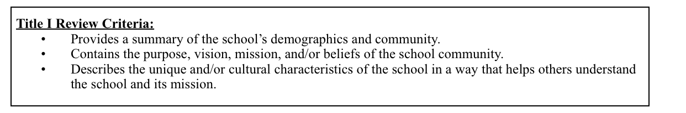

III. NEEDS ASSESSMENT
- The needs assessment is based on data that addresses the needs of all students—in regular education, special education, English language learners, virtual ed. students, etc. with particular focus on the needs of low-achieving students.
- The needs assessment should include:
  - Source(s) of data
  - Analyses of data
  - Student achievement indicators
  - Strengths and weaknesses based on the data analysis
  - Discussion of progress made in student achievement
  - Findings that lead to changes in priorities
- Reflective questions for comprehensive needs assessment:
  - Does the CNA reflect a comprehensive assessment of the strengths and challenges of the school?
  - Does the CNA extract the root causes of low student achievement?
  - Is there evidence to support the identified root causes? Are they sound?

A. DATA PROFILE
- Insert into this section or attach as an appendix a data profile that includes data from each of the four types:
    - Demographic Data: Who are we? Data on student populations (e.g. gender, sped, ELL, race/ethnicity, behavior), teacher and staff (e.g. qualifications, years of teaching, gender, race/ethnicity), parent and community (e.g. education, income, single family households.)
    - Perception: How do we do business? Culture, climate, values and beliefs (e.g. surveys)
    - Student learning: How are our students doing? Summative, formative, diagnostic (e.g. HSA, DIBELS, NWEA, Curriculum Based Measures, grades, ACT/Plan/Explore, etc.)
    - Programs and processes: What are our processes? Programs, instructional, organizational, administrative, continuous school improvement

DEMOGRAPHIC DATA

Student Enrollment
School Year | % of Boys | % of Girls | Total
Fall 2010 | 57% | 43% | 163
Fall 2011 | 56% | 44% | 168
Fall 2012 | 54% | 46% | 183
Fall 2013 | 53% | 47% | 188
Fall 2014 | 55% | 45% | 166

Gender by Grade
Grade | % Male | % Female
K | 63% | 37%
1 | 44% | 56%
2 | 18% | 82%
3 | 41% | 59%
4 | 35% | 65%
5 | 41% | 59%
6 | 47% | 53%
7 | 82% | 18%
8 | 50% | 50%

Percentage of Economically Disadvantaged Students
Fall 2011 | 62%
Fall 2012 | 60%
Fall 2013 | 60%
Fall 2014 | 70%

Percentage of IDEA Eligible Students
Fall 2011 | 14%
Fall 2012 | 15%
Fall 2013 | 19%
Fall 2014 | 19%

SPED Eligibility Categories Higher than State Average in 2014-2015
 | VSAS | State
Autism | 8.6% | 6.6%
OHD | 34.3% | 14.4%
SLD | 51.4% | 40.9%

School Population By Ethnicity Vs. SPED Population By Ethnicity 2014-2015
 | Enrollment | SPED | % Diff
Pac. Islander | 31.3% (n=57) | 42.9% (n=15) | 11.60%
White | 41.8% (n=76) | 37.1% (n=13) | -4.70%
Hispanic | 9.3% (n=17) | 2.9% (n=1) | -6.40%
Multiple | 8.2% (n=15) | 5.7% (n=2) | -2.50%

Percentage of English Language Learner Students
Fall 2011 | 1%
Fall 2012 | 1%
Fall 2013 | 1%
Fall 2014 | 1%

Student Ethnicity
Ethnicity Data | 2013-14 | 2014-15
White | 39% | 52%
Pacific Islander | 36% | 39%
Asian | 11% | 2%
Hispanic | 5% | 0%
Native American Indian | 4% | 5%
Other | 7% | 2%

Teacher Ethnicity
Ethnicity Data | 2014-2015
White | 96%
Pacific Islander | 4%
Asian | 0%
Hispanic | 0%
Native American Indian | 0%
Other | 0%

Highly Qualified Teachers
2013-14 | 96%
2014-15 | 96%

Number Of Teachers With More Than 5 Years of Teaching Experience At VSAS
2014-15 | 10

Number Of Discipline Referrals
2014-2015 | 129
*as of 2/25/2015

Fully Seated Board
2013-14 | Yes
2014-15 | Yes

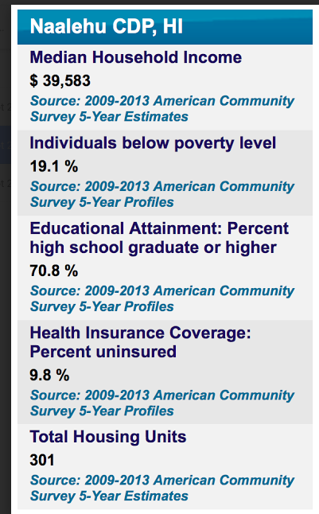
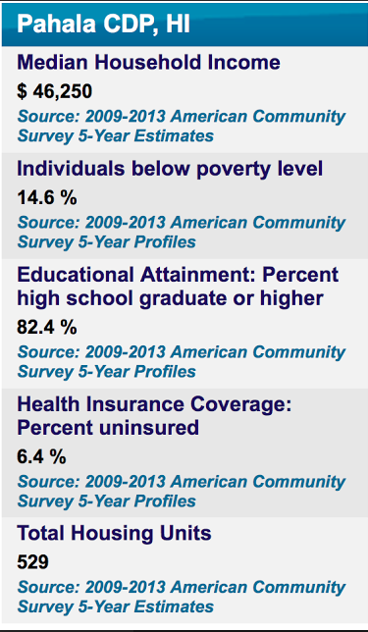
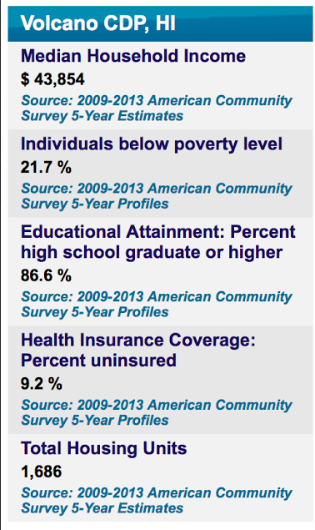
Community Demographics

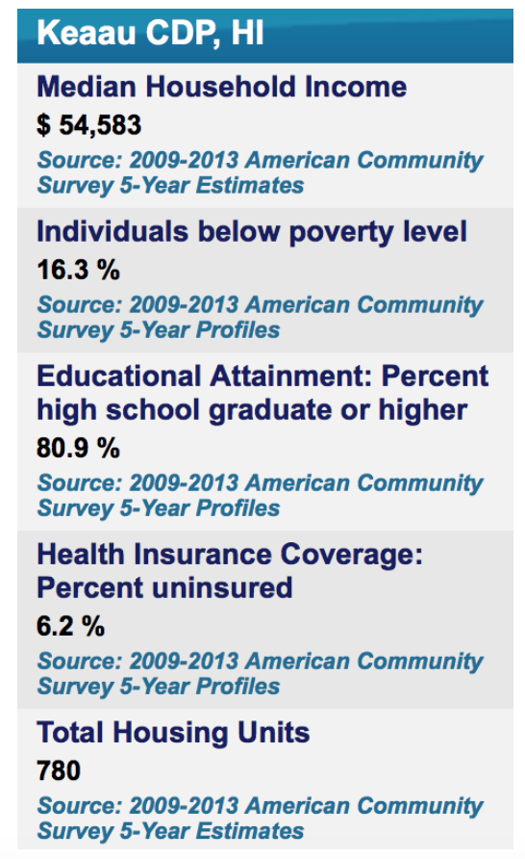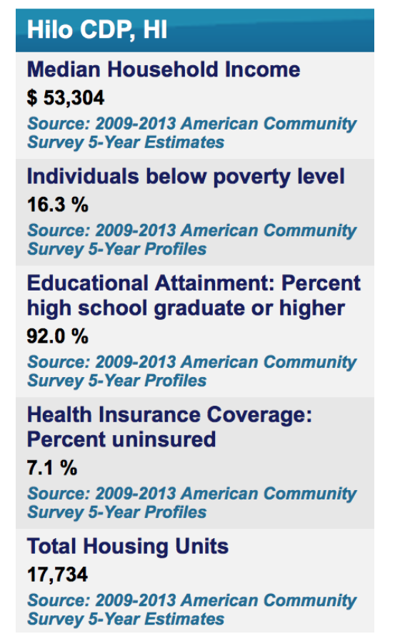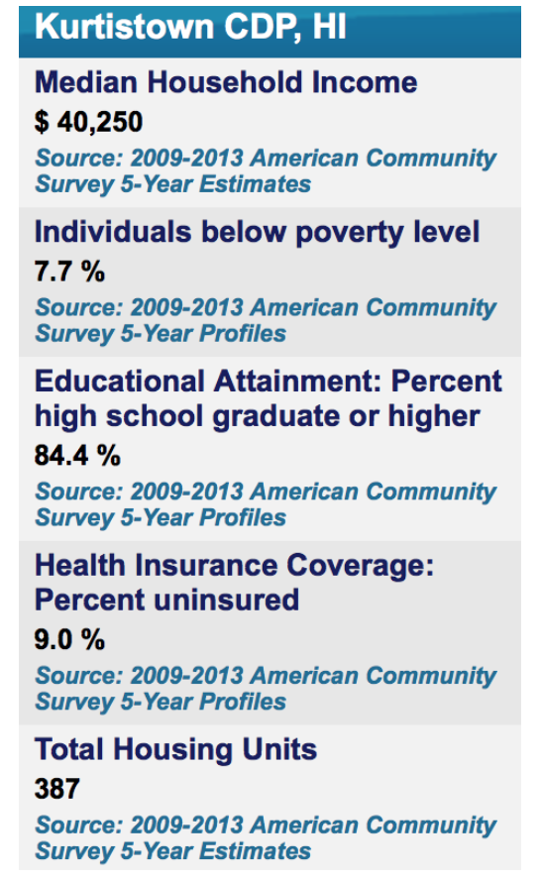

TOWN AND DISTRICT RESIDENCE OF STUDENTS
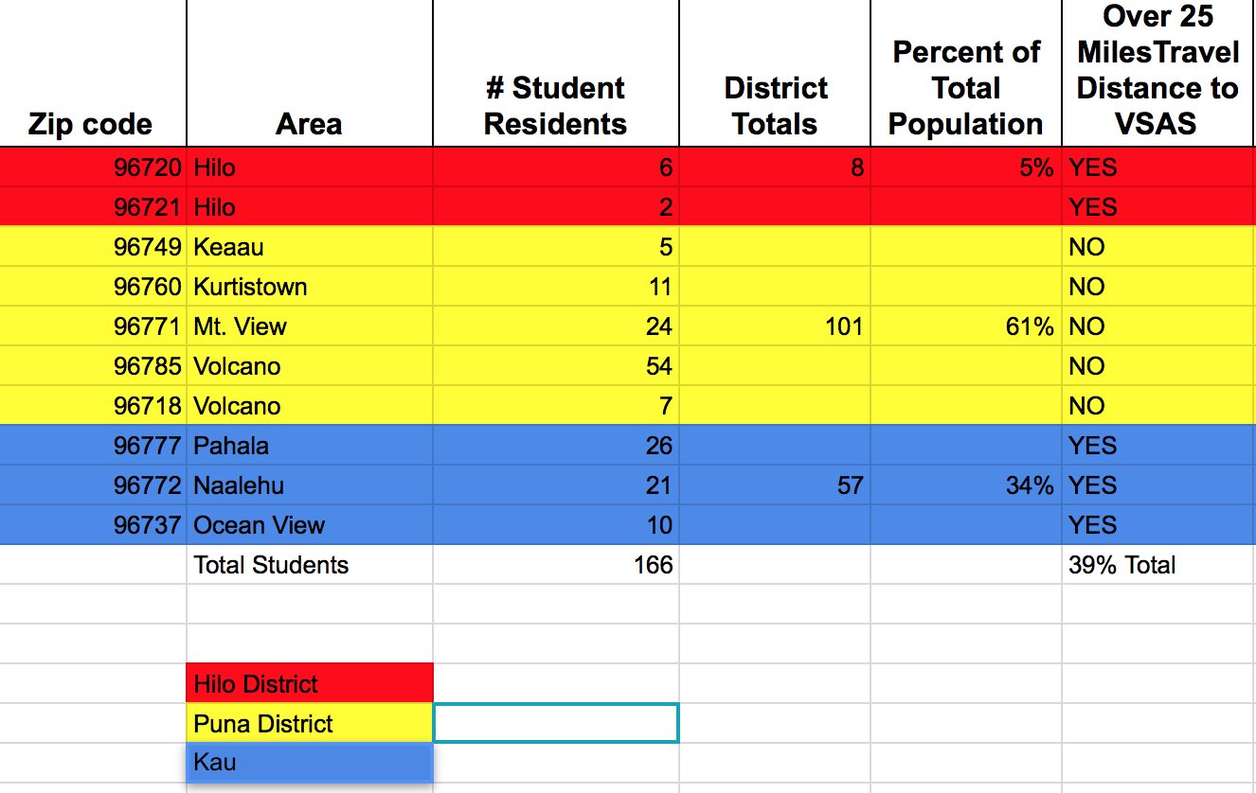

PERCEPTION DATA

See Appendix 2: Student, Parent, and Staff Questionnaires

STUDENT LEARNING DATA

See Appendix 1: LDS Data Profile for HSA and ACT data

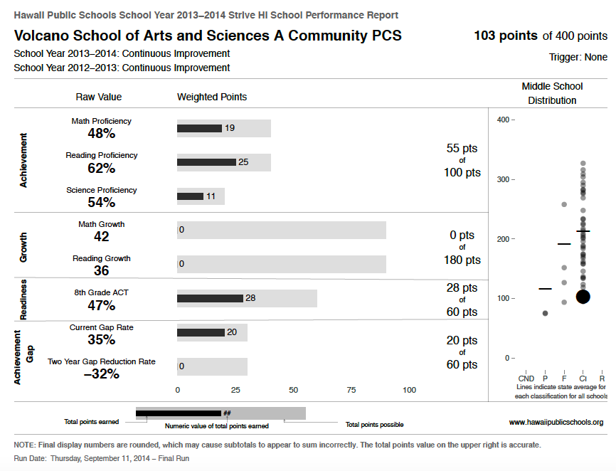
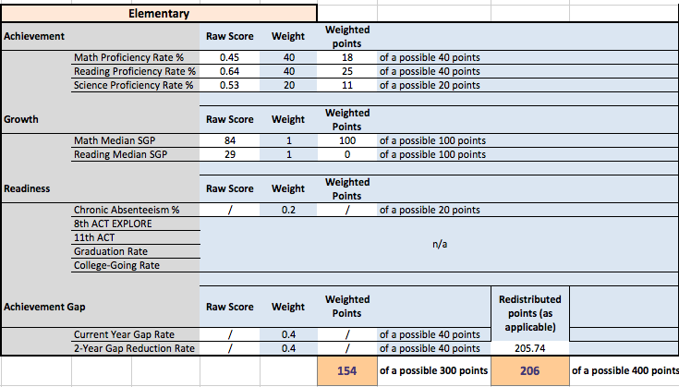
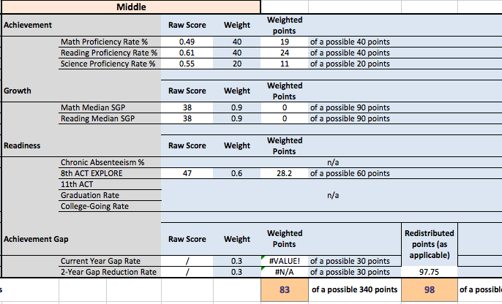

NWEA Fall 2014 by Ethnicity
 | Below Standards | Proficient | Advanced
American Indian or Alaskan Native | 35.0% | 40.0% | 25.0%
Asian | 11.8% | 23.5% | 64.7%
Black or African American | 71.4% | 14.3% | 14.3%
Native Hawaiian or Other Pacific Islander | 83.5% | 13.7% | 3.6%
White | 49.5% | 24.5% | 26.1%

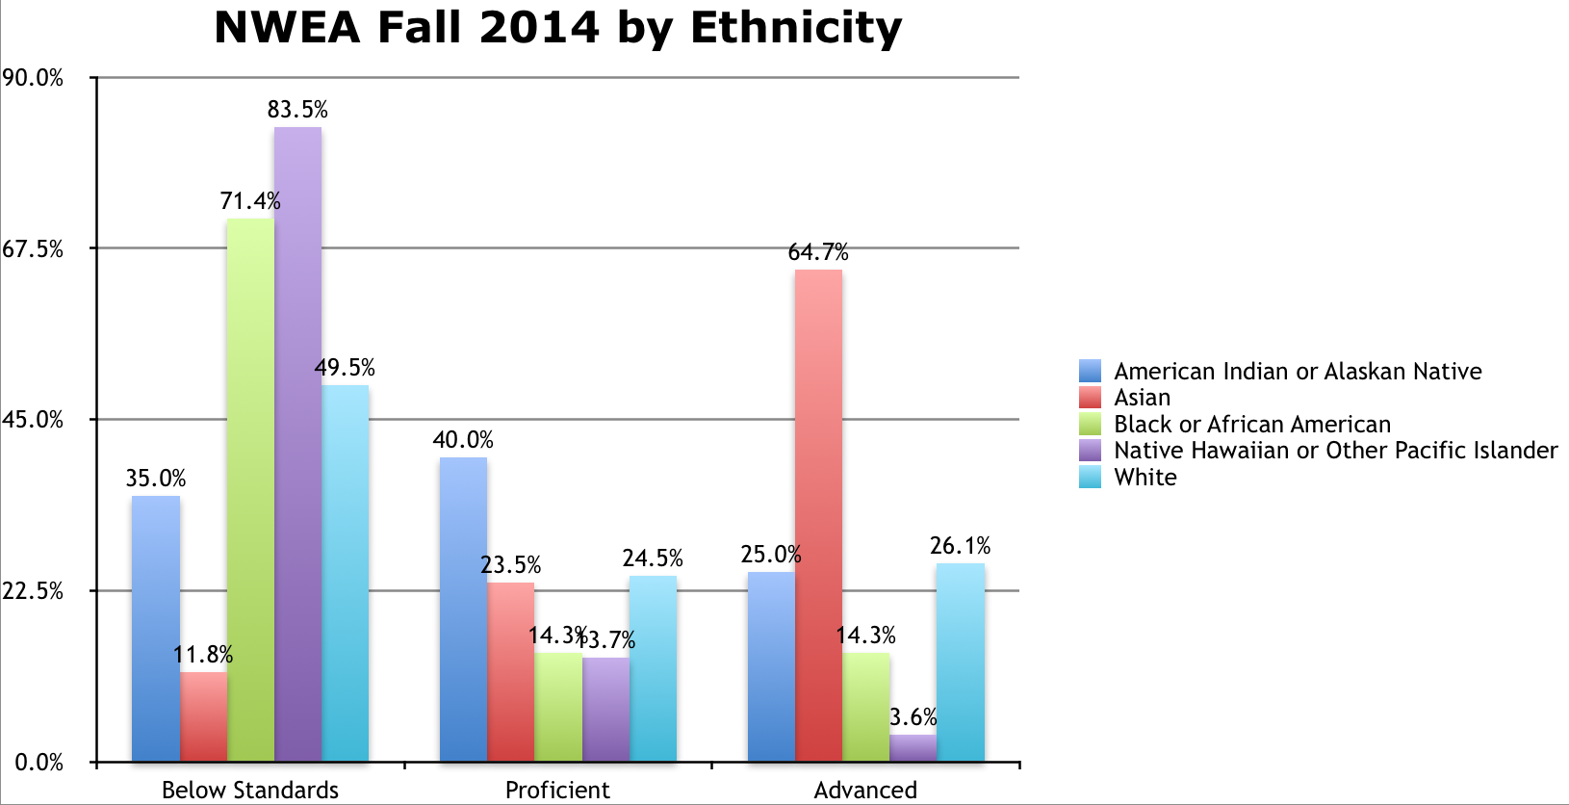

NWEA Fall 2014 by SPED/504
 | Below Standards | Proficient | Advanced
Non SPED/504 | 49.5% (n=137) | 27.1% (n=75) | 23.5% (n=65)
SPED | 91.8% (n=78) | 2.4% (n=2) | 5.9% (n=5)
504 | 100.0% (n=6) | 0.0% | 0.0%

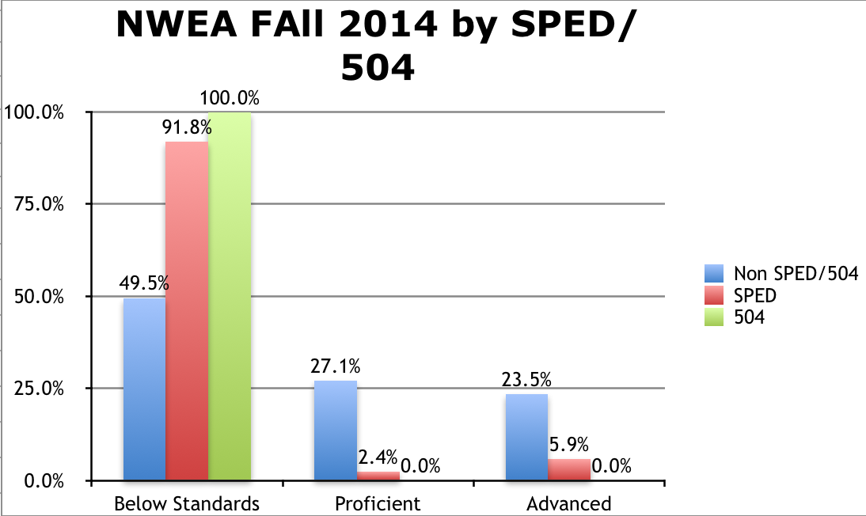

NWEA Fall 2014
Scores below 40%

Criteria | n
Total below 40% | 41
SPED below 40% | 20
504 below 40% | 0
Nat. Hawn/Pac Islander below 40% | 19
SPED + Nat.Hawn/Pac Islander below 40% | 8
* N represents total scores on all assessments. Students took between 1-3 assessments each.

PROCESS DATA

SCHOOL PROCESSES INVENTORY

instructional  processes | organizational  processes | administrative  processes | continuous school improvement processes | programs
- Curriculum  - Instructional strategies  - Assessments (NWEA, DRA, WJ III, Grade, Key Math, Smarter Balanced, ACT, HSA Science, NAEP, WAP-T/WIDA)  - Differentiated Instruction  - Direct Instruction  - Grading (standards-based)  - Scaffolding  - Co-teaching  - Small group instruction  - Homework  - Academic conversations with students  - Classroom discussion (teacher talk, student-to student talk, student to teacher talk)  - Classroom assignments (types of tasks, choices, projects, collaboration)  - Inquiry process  - Student reflection and self-assessment  - Standards implementation  - Technology integration  - Tutoring  - Learning Snapshots  - Student-led Conferences  - Learning Trips  - Guest Speakers  - Volunteers  - Partnerships  - Specials/electives | - Teacher collaboration  - Data teams  - Data use  - Leadership structure (leadership teams)  - PLC – pod and staff meetings  - RTI  - Mentoring  - Instructional Coaching  - Referral process  - Policies and procedures  - Parent involvement  - Teacher hiring  - Teaching assignment  - Teacher renewal (professional learning)  - Prof reflection  - Teacher evaluations  - Inquiry process  - Problem solving  - Prof discussions and support  - Teacher observations  - Mission/vision  - Governing Board  - Office procedures (e.g. attendance, communication, materials/supplies, student cum files, FRL count)  - Infoflo  - Website  - Student Information System  - Learning Management System (report cards)  - Transportation  - Meal program (breakfast/lunch) | - Scheduling of classes  - Class sizes  - Discipline strategies  - Student groupings  - Policies and procedures  - Enrollment in different courses/programs/program offerings  - Retention  - Attendance program  - Attrition  - Teacher hiring  - Teacher assignments  - Teacher certifications  - Teacher turnover rates  - Leadership turnover rates  - Number of support personnel  - Data collection  - Payroll  - Audits (lunch, financial, educational)  - Leave/HR  - Governing Board  - Friends Board  - Union  - Facility development and maintenance  - Assessment coordination  - Technology coordination, support, planning  - Student services coordination  - Student support services | - Data analysis & use  - Contributing cause analysis  - Vision/mission  - Continuous School Improvement planning  - Leadership  - Professional learning  - Partnerships  - Evaluations  - Self-assessment  - Steering Committee  - Alumni tracking  - Accreditation Self Study  - Title I  - Title II | - A+  - Afterschool Enrichment  - Service Learning  - SPED  - Spring Musical  - WAVOC  - MS Theater  - Family nights  - Peaceful Class  - Counseling  - Specials/Electives  - IDP  - ELL

B. ANALYSIS OF DATA

- Use the suggested format or replace with any format to identify strengths and areas of need across the four

Demographic DATA

Strengths | Challenges
OVERALL  - Small class sizes (DATA)  - Low student to instructional adult ratio (DATA)  - School of choice in general (School Profile, Lottery Data)  Returning versus new students  GENDER  More equitable gender distribution (Still a 10 % gap, DATA)  ETHNICITY  - Diverse ethnic population  - Increase in Hispanic and Pacific Islander categories  - (DATA)  SPED  - 2013-2014 Higher than state average for autism (8.6% vs 6.6%) - VSAS school of choice  - SPED ethnicities are generally similar to enrollment ethnicities (DATA)  - Gradual increase in SPED population  - (improvements in the referral eligibility process ~ SLD)  - School of choice for students with IEPs (DATA)  ELL  - Small percentage of ELL students (DATA)  TEACHERS/STAFF  - 96% HQ teaching staff  - 10 teachers have more than 5 years of teaching experience at VSAS.  BEHAVIOR  - Number of referrals  LEADERSHIP/GOVERNANCE  - Local governance of school with a fully seated board | ENROLLMENT  - Unstable enrollment  2011-12 2012-13 2013-14 2014-2015  153 182 182 166  Returning versus new students  LOCATION  - 39% of students travel 25 or more miles each way to attend VSAS  GENDER  - Higher percentage of male students than female students  - Gender of teachers not proportionate to gender of students. Higher percentage of female teachers than male teachers  - Large gender imbalance in some classes  2014-15  7th grade - 3 girls, 14 boys  4th grade - 6 girls, 11 boys  2nd grade - 14 girls, 3 boys  ETHNICITY  - Decrease in Asian and White populations  - Non low SES population is declining (33-21 from 2010-2014)  LOW-SES  - Low-SES is increasing  11-12 12-13 13-14 14-15  Low-SES 62%* 62.6% 68.7% 70.4%*  *based on actual data. FRL counts inaccurate  - Low-SES is 15% higher than state average  - School’s low-SES percentage (70.4%) does not reflect the SES data from the local communities (Volcano = 21.7%, Pahala = 14.6%, Naʻalehu = 19.1%)  SPED  - SPED population is higher than the state average  - SPED population in the middle school is higher than the overall school average  - Special education population is increasing  11-12 12-13 13-14 14-15  SPED 14.4% 14.8% 19.2% 19.2%  - Higher than state average in eligibility  VSAS State  Autism 8.6% 6.6%  OHD 34.3% 14.4%  SLD 51.4% 40.9%  - Increases in autism, OHD, SLD over three years  - Increase in student SLD population  - High percentage of OHD (34.3% compared to 14.1 in state)  - High percentage of Pacific Islanders in SLD and OHD  - Sped distribution - 11.6% more pacific islanders in sped than enrolled in school. Other significant differences in ethnicity distributions between SPED and enrollment are as follows:  Enrollment SPED % Diff  Pac. Islander 31.3% (n=57) 42.9% (n=15) 11.60%  White 41.8% (n=76) 37.1% (n=13) -4.70%  Hispanic 9.3% (n=17) 2.9% (n=1) -6.40%  Multiple 8.2% (n=15) 5.7% (n=2) -2.50%  Wide range of needs with small populations and small staff - 2 ELL, 3 autism, etc.  ATTENDANCE  - Attendance is lower than state and other charter schools  - Kindergarten cohort (from 2012-2013, for two years, 81.5% in 12-13 and 80% in 13-14) had lowest attendance levels with low SES (75.3%) and SPED attendance (72.4%)  - Some students who are chronic absentees  - About 10% absence each day  ELL  - ELL enrollment is low (1.1%) compared to state (7.3%) challenge to develop expertise to support ELL students  OVERALL  - Processes for collecting data accurately  - Gaps in data collection  TEACHERS/STAFF  - Teacher ethnicity does not reflect student ethnicity  - Teacher gender does not reflect student gender  - Changes in office staff --The entire office and Administrative staff changed over the past 4 years (1 Administrator, 1 Business Manager, 3 Office Clerks, new Assistant Director position)

What are some implications for the continuous school improvement plan?
- Develop teaching models, systems, and programs to better meet the diverse needs of our special education students (e.g. Autism, SLD, OHD, ED)
- Investigate reasons for higher pacific islander population with disabilities.
- Identify/develop strategies to better support high number of pacific islanders, males, and low-SES.
- Develop and implement systems to support small populations with needs (e.g. ELL, autism)
- Further refine and implement RtI system and processes
- Provide professional development in RtI strategies including data collection, common understanding of purpose of RtI, and intervention strategies
- Provide tools and support for teachers for data collection and targeted interventions.
- Conduct regular child study team meetings to evaluate the effectiveness of interventions and determine changes in instruction and level of intervention (e.g. level 2, 3, sped referral)
- Include Critical Friends protocols in processes for examining student challenges
- Clarify roles and responsibilities for serving students with learning challenges (e.g. classroom teachers, special education teachers, EAs, tutors, admin)
- Clarify, model, and communicate RtI expectations for teachers and support staff.
- Increase number of teachers with areas of expertise to serve as mentors for faculty and staff
- Investigate and implement strategies to establish a positive campus climate for students and adults
- Improve systems and processes for collecting, tracking, analyzing data to inform instruction and for continuous school improvement.
- Improve data system for tracking and communicating attendance within staff and with parents.
- Engage students in leadership roles and positive campus culture activities.
- Expand programs and activities related to student interest and needs.
- Address vocabulary and language skills needs of all students (standard English vocabulary and usage, academic vocabulary, and content specific vocabulary)
- Continue free food program for all students
- Have food service personnel serve breakfast and lunch
- Further develop and improve onboarding procedures for new teachers, staff, and board members
- Improve strategies for differentiation and evidence that those strategies are implemented
- Expand arts integration in curriculum and instruction
- Implement positive discipline school-wide and identify areas that are not aligned to the positive discipline model (eg CHILL)
- Identify and analyze discipline data by type of incident, location, time of day, students involved, teachers and staff involved, demographics of the student
- Expand programs to challenge, and engage high achieving students
- Deepen alignment of programs and instructional strategies to the school’s mission and vision
- Investigate the effect of the free breakfast and lunch program on attendance, behavior, and academic performance
- Research how other schools effectively address attendance problems

- Hire an assessment, academic, instructional, data coach to develop and implement systems and processes and support alignment practices between grade levels

Looking at the data presented, what other demographic data would you want to answer the
question Who are we?
- Lottery Data ~ How many people are interested and in what grade levels?
- Waiting List ~ How many, age groups, geographic data?
- Discipline Data ~ Referrals and Suspensions (type of incident, location, time of day, students involved, teachers and staff involved, demographics of the student)
- Food Program ~ Implementation date, effect that it has had on attendance, behavior, and achievement
- More disaggregated data on attendance including the reasons for absence
- How do we disaggregate data for students from different geographic areas who attend our school?
- Collect student and teacher attrition data through exit surveys
- Rates of parent attendance at school events and parent conferences
- Alumni Tracking
- Leadership Stability and Structure
- Non-teacher staff stability and structure

Perception DATA

Strengths | Challenges
STUDENTS  - High scores (averages in the 3s and 4s)  - Overall improvement 2013 to 2014  Highest items:  - My teachers believe I can learn  - Family wants them to do well and thinks that they can do well  - Students thought that they could be better students  - Teachers treat me with respect  Subgroups  - Elementary scores average in 4 to 5 range  - 6th grade had more positive scores  - 2nd grade had generally higher scores than other grades (high number of girls in class)  - Asians had the highest favorability rate  Comments:  - Choice activities  PARENTS  - Overall trend of parent responses higher this year than last year  - This year all parent responses are between 4 and 5. Last year, all but 4 responses between 4-5.  - Response rate was higher than previous years rate (62 compared to 45)  Highest items:  - Feel welcome and perceive a good public image of VSAS  - Respect teachers  - Think that teachers respect the students  - Think that their child is safe going to and coming from school  - Support student learning at home  Subgroups  - Parent perceptions differ somewhat according to ethnicity  Comments  - Parents value small class sizes, off campus learning opportunities, and highly qualified teachers  - Parents value school location and environment  - Student like to come to school  - Communication with administration  STAFF  - Overall positive  - Most items stayed the same between November 2013 and 2014  - Questions related to administrators improved overall between the two years  Highest items  - Learning can be fun  - Think for myself  - Believe in parent involvement  - Believe in differentiation, a threat free environment, communication with parents  - Every student can learn  - I love seeing the results of my work with students  - I love to teach  - Learning is fun in my classroom  - Teachers work well with special education and English learner students  Subgroups  - Teachers of primary grades rate the school consistently higher than teachers of middle school grades  Comments  - Staff appreciates mission and vision, shared decision making, and academic freedom and flexibility  - Like small school | STUDENTS  - Low response rate (120 of 166)  - 5th graders responded with lowest scores  Lowest items:  - Students at my school are friendly and other students treat me with respect were comparatively lower.  - I have choices in what I learn was comparatively lower than other areas  - My teachers listen to my ideas.  Subgroups  - Non-caucasian students are less clear than caucasian students about what they are expected to learn.  - Caucasian students rated lowest on other students treat me with respect  - African Americans had the lowest favorability rate  - Boys especially want more freedom at VSAS  Comments:  - Need more challenging math, advanced math section, more hands on activities in math.  - Students feel peer relations with each other could improve. (7 out of 24 comments on things that needed to be improved from middle school students)  - Lack of playground  PARENTS  - Low response rate 62 out of 112.  Lowest items:  - Student show respect for other students  - Knowing how well my child is progressing  - I like the student reports and progress reports  - The school succeeds at preparing children for future work.  Subgroups  - Parents of Caucasian rated lowest on other students treat me with respect  - Parent perceptions differ somewhat according to ethnicity  - Caucasian parents scored lower on academics than non-caucasian parents  - Parents of 5th and 6th grade students rated lowest across items  - Parents of 4th grade student rated lower than other parents on items: respect for others, I respect the school principal, and assessment practices are fair.  - Parents of 5, 6, 7, 8 grade students rated lower my childʻs teacher helps me to help my child learn at home and also rated lower I know how well my child is progressing in school  Comments  - Inadequate facilities  - Better communication, facilities, and differentiation  STAFF  Low response rate (56%)  Lowest items:  - Morale is high on the part of:  o Students  o Administrators  o Support staff  o Teachers  - Teachers in this school communicate with each other to make student learning consistently across grades  - I believe the instructional program at this school is challenging  - The school provides an atmosphere where every student can succeed  - Quality work is expected of all students at this school  - Quality work is expected of all adults working at this school  - The school has a good public image  Negative trend items:  - Challenging and quality student work  - Atmosphere where every student can succeed  - student morale  - Teacher communication for consistency across grade levels  Subgroups  - Considerable variation between staff ethnicity, grade taught, role, and number of years teaching  - Teachers of middle school grades rate the school consistently lower than teachers of elementary grades, especially for items:  - others are clear about my job  - teaching to the state standards  - I feel like I belong  - learning is fun  - I am recognized for good work  - Shared decision making  - effective instruction  - I love working here  - effective action plan  - Middle school rated between 3 and 4 on all but two items:  - others are clear about my job  - teaching to the state standards  - quality work is expected of all students at this school  - morale is high on the part of students  - Instructional assistants scored low in both standards questions and ability to develop their skills  - Teachers with 11 or more years of experience generally rated lower  - Teachers with 7-10 years rated lower on state standards questions but higher on all other questions.  Comments  Areas for improvement:  - Facilities are not conducive to learning  - Sending 5th grade to MS is a tricky, difficult situation  - Transparency at the administration level  - Need to explore gifted or accelerated program  - Some teachers not sympathetic to student needs

What are some implications for the continuous school improvement plan?
- Explore dynamics between students with regards to bullying related to ethnicity/race and grade level
- Integrate more strategies to improve social skills, respect, and communication (social emotional learning strategies)
- Improve communication between students and teachers so that students feel heard and that their ideas are considered by teachers
- Implement more engaging math instruction
- Provide more hands on active learning opportunities that both sparks and responds to student curiosity
- Develop ways in which students can be more active or be involved in more physical activity
- Institute more rigor to ensure that students are adequately prepared for future work (higher expectations)
- Expand/increase arts integration activities
- Develop student ability to be competent self assessors
- Develop or adopt a more friendly/informative manner of informing parents of their children’s progress
- Improve the satisfaction rates of 5th and 6th grade parents
- Engage middle school parents for ways to better help their child at home
- Prioritize facility improvement and new campus development
- Find ways to increase morale across all stakeholders
- Institute more articulation time between teachers
- Improve communication between teachers, from grade level to grade level, regarding student needs
- Clarify grade level expectations
- Identify key authentic community building and experiential learning activities for each grade level for students to have something to look forward to each year
- Ensure that all staff believe that all students can succeed
- Improve consistency of quality work across all adults at the school
- Improve the public image of the school
- Explore understanding of Common Core State Standards among instructional staff to ensure commitment
- Professional development on unpacking common core standards
- Clarify roles and responsibilities of all staff
- Improve satisfaction rates of teachers with 11 or more years of service at the school and those in the middle school
- Improve transparency at the administrative level
- Ensure that differentiation is employed to address needs of all learners
- Effectively implement school wide classroom management plan (positive discipline and responsive classroom
- Work on a school-wide culture where students are excited about learning
- Increase student driven instruction
- Improve goal setting procedures and develop essential question
- Lispand communication with parents and the broader community through the online formats (school website, online reporting systems, teacher and class blogs)
- Provide professional development for staff on how to integrate technology in the classroom (eg online learning, blogs, websites)
- Utilize parent, student, and community volunteer skills and expertise to support school initiatives and needs
- Highlight classroom and school activities as well as successes
- Further develop and implement RtI systems and processes
- Continue NWEA and improve consistency.
- Identify/improve progress monitoring tools and processes
- Implement strategies to increase response rate of surveys
- Improve processes for developing surveys as well as collecting and analyzing information from surveys from school events, student conferences, and staff meetings and professional development sessions
- Develop a long term technology plan and pursue funding and resources

- Hire an assessment, academic, instructional, data coach to develop and implement systems and processes and support alignment practices between grade levels

Looking at the data presented, what other perception data would you want to answer the
question How do we do business?
More information on what students mean by the response of “I can be a better student” and how teachers could support this.

Investigate existing surveys (e.g. Math Night, Astro Night) and streamline the survey process.
Additional and uniform surveys from school events, student conferences, staff meetings, and professional development sessions.

Student Learning DATA

Strengths | Challenges
OVERALL  - Started the process of a school-wide data collection system  MATH  - Numbers of actual cohort students gaining in growth is increasing 28 out of 73 (HSA growth from 2012/13 to 2013/14 grades 3-8, compared individual students score from one grade to the next ~ Only students with scores from 2 years were counted)  - Student growth percentile for math in elementary grades is strong (Math Median Student Growth Percentile = 84)  - Instituted NWEA testing  READING  - Proficiency in reading of our SPED students and Low SES students is higher than the state average for categories  SCIENCE  - Science scores are higher than the state average  - Low SES status did not affect achievement on science assessments (Grade 4 - 2011-2012 54% proficient at VSAS vs. 32% proficient state average, 2012-2013 62% proficient at VSAS vs. 32% state average, 2013-2014 42% proficient at VSAS vs. 40% state average. Grade 8 - 2011-2012 70% proficient at VSAS vs. 32% state average, 2012-2013 36% at VSAS vs. 21% state average, 2013-2014 44% at VSAS vs. 25% state average  ACT  - Performed higher than state average on 8th grade ACT (DATA) | OVERALL  - Systems of data collection, analyzing, and tracking  - Selecting assessments that inform instruction (and paying for them) and using them appropriately  - Changing landscape in education (standards and tests)  MATH  - High fluctuation of percentage of students proficient in math from 2010 to 2014.  - Decline in percentage of students proficient in math from 2011 to 2014 (64.87% 2011-2012, 51.75% 2012-2013, 48.21% 2013-2014)  - Pacific Islanders performing lower than white students  - All categories of students are performing lower than state averages in 2013-2014  - Three cohorts (4th to 5th, 5th to 6th, and 6th to 7th) from 2012-2013 to 2013-2014 had significant drops in scores  - Low growth in math in middle school grades (APF - simulated strength line)  - Proficiency among our SPED population is 30-50% lower than for non-SPED students.  READING  - Overall trend of proficiency by cohort is downward  - Non low SES proficiency in reading is declining (87% to 70% over the last four years 2010-2014)  - Pacific Islanders proficiency in reading is declining (81% to 51% over the last four years 2010 to 2014)  - Proficiency of males at VSAS is lower than the state average (55% vs. 64% in 2013-2014)  - Proficiency of males at VSAS is lower than proficiency of females (55% vs. 72%)  - Proficiency among our SPED population is 45% to 60% lower than the non-SPED population in reading  - Students with multiple ethnicities are performing 19% lower than the state average in 2013-2014  - Low SGP growth in reading across the whole school in 2013-2014  SCIENCE  - Proficiency has declined over the years in 8th grade (75% in 2010-2011, 65% in 2011-2012, 47% 2012-2013, 52% 2013-1014)  - No SPED students were proficient in 2013-14  - 4th grade - about half of students are not proficient (56% proficient)  - Females are less proficient than males in 4th and 8th grades combined (2012-13 40% females vs. 63% males; 2013-14 41% females vs. 64% males)  - Females in 4th and 8th grades combined were below the state average (41% vs. 43%)  - Females in 8th grade were below the state average in 2012-13 (25% [n=2] vs. 28%) 2013-14 (25% [n=2] vs. 34%)

What are some implications for the continuous school improvement plan?
- Improve strategies to meet the needs of our diverse learning population and low performing subgroups at VSAS
- Improve instructional strategies as well as discipline and classroom management approaches to address the needs of our middle school population
- Develop a workable plan for the restructuring by the end of the school year
- Improve data collection, analysis, and tracking on academics and behavior to better inform proactive and effective RtI and other interventions.
- Improve data tracking to account for the high impact of an individual student’s performance on the class and schools performance profile
- Improve retention of students from year to year
- Collect data on why students are leaving VSAS
- Cultivate a shared understanding of the school’s mission and vision
- Advertise the school’s mission and vision with examples
- Continue to align curriculum, policies, instructional programs, practices and school-wide climate and culture with the mission and vision of the school
- Expand arts integration in curriculum and instruction
- Engage and incorporate new students into the school culture
- Incorporate new students into existing procedures
- Increase exposure to stories of and role models that connect to the low performing groups at VSAS (females {science}, Native Hawaiian or Pacific Islander, SPED, low SES)
- On-going multi-media compilation of alumni stories, profiles, and experiences
- Provide students with choices and a variety of learning activities
- Continue reading buddies
- Provide more hands on active learning opportunities that both sparks and responds to student curiosity
- Incorporate science process skills (e.g. inquiry and observation) into a wider variety of student activities
- Clarify grade level expectations and vertically align curriculum
- Establish common instructional approaches across grade levels with spiraling, scaffolding content and skills (e.g. research, study skills, writing/reading instruction)
- Adopt a uniform, highly effective, and CCSS based Math curriculum and instructional strategies
- Develop common, highly effective intervention strategies and effective RtI processes
- Further develop and implement consistent practices of highly effective instructional strategies and interventions
- Hire an assessment, academic, instructional, data coach to develop and implement systems and processes and support alignment practices between grade levels
- Utilize expertise from faculty, staff, administration, board members, parents, and community members for professional development
- Utilize pod meetings, learning snapshots, and collaboration days (21 hours) to align content and curriculum
- Analyze the effectiveness of the current leadership, collaboration and support structures and adjust as needed
- Improve support and accountability for implementation of expectations
- Encourage staff to implement and model constructive positive solutions
- Improve professional development program for instructional assistants
- Increase participation of instructional assistants in professional development and staff meetings
- Improve co-teaching practices among general education teachers, special education teachers, team teachers, and instructional assistants.
- Restructure and clarify the roles and responsibilities of support staff and include this in beginning of the year and onboarding training

- Implement more engaging math instruction
- Provide more hands on active learning opportunities that both sparks and responds to student curiosity
- Institute more rigor to ensure that students are adequately prepared for future work (higher expectations)
- Develop student ability to be competent self assessors
- Develop or adopt a more friendly/informative manner of informing parents of their children’s progress
- Engage middle school parents for ways to better help their child at home
- Institute more articulation time between teachers
- Clarify grade level expectations
- Ensure that all staff believe that all students can succeed
- Improve consistency of quality work across all adults at the school
- Explore understanding of Common Core State Standards among instructional staff to ensure commitment
- Provide professional development on unpacking common core standards
- Clarify roles and responsibilities of all staff
- Ensure that differentiation is employed to address needs of all learners
- Effectively implement school wide classroom management plan (positive discipline and responsive classroom
- Work on a school-wide culture where students are excited about learning
- Expand/increase arts integration
- Increase student driven instruction
- Improve goal setting procedures and develop essential question
- Listen to student ideas and provide them with choices in learning cumulating in a 7th/8th capstone course/project
- Provide professional development opportunities on how to be more responsive to cultural differences
- Improve communication systems with parents such as through an online progress reporting system
- Provide professional development for staff on how to integrate technology in the classroom (eg online learning, blogs, websites)
- Highlight classroom and school activities as well as successes
- Further develop and implement RtI systems and processes
- Continue NWEA and improve consistency.
- Identify/improve progress monitoring tools and processes

Looking at the data presented, what other student learning data would you want to answer the
question How are our students doing?
Identify and document what interventions have been done with specific students/classes (SPED, Title 1, Tutoring)

What materials and what trainings does everyone have/need?
What core trainings are necessary for all staff to have in relation to our mission and vision?
What follow up is necessary for successful implementation?

Who is overseeing and scheduling?

What other assessments do we use to screen students to determine student needs?

Ratio of males to females as it relates to academic and discipline data.

Program & Process DATA

Strengths | Challenges
- Diverse program offerings for students and families compared to traditional schools  - Structure for pod and staff meetings is established  - Steering committee allows for shared decision making  - A number of staff members are trained in Critical Friends Groups protocols and use them to present information and facilitate discussions  - Student-led conferences are in place  - Small class size  - Weekly staff updates  - Infoflo to communicate weekly with families  - School wide assessments are administered  - There is agreement to implement CCSS  - Varied strengths in staff members  - General direction to move towards  - Lots of adults who know students well  - Community-created, student-centered Mission/vision  - Local governance of school  - Free meal program (breakfast and lunch for all students) | - Facilities  - Lack of technology and training for staff to incorporate technology in instruction  - Lack of a long term technology plan  - Maximizing use of support staff  - Some support staff have not received adequate school-specific training  - Implementation and follow-up with PD; many processes are not strategic, consistent, or systemic  - Board yearly turnover results in unclear and inconsistent direction  - Lots of testing compared to time for learning  - Turnover in key positions and small staff results in fragile systems with gaps in expertise and training challenges.  - Recruitment and hiring processes  - Coordination with DOE and statewide systems  - Funding  - Changing landscape in processes to address student needs (e.g. SPED eligibility and services, RtI)  - Collecting, analyzing, and tracking data  - Onboarding procedures  - Communications/expectations for processes and procedures  - Lack of clear roles and expectations  - Oversight and supervision of teachers and staff  - Implementation of evaluation systems  - Availability of qualified substitutes for teachers and office staff. No subs for admin.  - Standards are not unpacked and curriculum is not articulated across grade levels  - Use of different assessments from grade to grade; not coordinated  - Grading process is cumbersome, not aligned to standards, and not clear to all stakeholders  - Homework processes are inconsistent. Students often do not complete homework. Lack of agreement on the purpose of homework.  - Attrition  - Attendance  - Differentiation is not implemented in all classroom  - Instruction is not effectively differentiated to meet the needs of all students  - Time and money to support resource classes, electives, and family events  - Communication between teachers for better vertical alignment and attainment of mission/vision  - To realize our school’s mission/vision  - Decision making is often driven by financial/organizational concerns or constraints rather than by the school plan and what we think is best for students  - Scarcity limits implementation of continuous school improvement plans  - Implementing self-assessment and reflection as part of school culture for students and adults  - Maintaining ongoing partnerships  - Not one person who can coordinate volunteers. No PTA/consistent parent involvement/volunteer group--due to small school community and increased workload as a charter school.  - Staff support and belief in mission/vision and PD opportunities  - Productive professional discussions  - Attendance monitoring and effective intervention  - Supporting staff in implementing changes  - Follow-up and accountability (consequences) for staff when not meeting expectations  - Volunteer opportunities, encouraging, tracking, etc.  - School population comes from a wide geographic area

What are some implications for the continuous school improvement plan?
- Identify deficiencies in implementing school improvement procedures
- Effectively implement the recommendations in previous continuous school improvement plans.
- Provide cross-training for staff
- Clarify expectations for processes and procedures for new and existing staff
- Improve systems and processes for collecting, tracking, analyzing data to inform instruction and for continuous school improvement.
- Further develop and improve onboarding procedures for new teachers, staff, and board members
- Clarify, model, and communicate RtI expectations for teachers and support staff.
- Improve processes for developing surveys as well as collecting and analyzing information from surveys from school events, student conferences, and staff meetings and professional development sessions
- Develop a long term technology plan and pursue funding and resources
- Hire an assessment, academic, instructional, data coach to develop and implement systems and processes and support alignment practices between grade levels
- Prioritize facility improvement and new campus development. Revisit staffing and organization structure to accommodate facility development needs
- Improve communication and coordination between VSAS board and Friends board for making progress toward shared goals and to take on more of the work.
- Analyze the effectiveness of the current leadership, collaboration and support structures and adjust as needed.
- Provide trainings that represent the core of our mission/vision for all staff
- Improve recruitment, hiring, and retention practices for all staff
- Assess and refine teacher evaluation system including establishing supports and probationary measures for ineffective staff
- Establish mentoring system for new and ineffective teachers
- Further develop induction processes for new teachers
- Further develop and implement evaluation system for staff
- Improve coordination and coordination of state
- Improve training and understanding of DOE culture and systems
- Continue lobbying for funding and educating stakeholders on funding needs
- Educate teachers and parents on new procedures for special education eligibility and response to intervention
- Clearly document roles, responsibilities and processes
- Formalize procedures for leadership coverage and communication
- Adopt an improved SIS/LMS program that fits with our school’s needs and mission and vision
- Expand arts integration in classroom activities
- Communicate our shared mission and vision to all stakeholders
- Formalize shared responsibility to working towards mission and vision
- Continue initiative to hold some school activities in Kau

Looking at the data presented, what other program and process data would you want to answer the
question What are our processes?

C. SYNTHESIS OF FINDINGS
- Synthesize analysis data into 5–15 key strengths and challenges.
- Identify 1–3 root causes of low student achievement.

Key Strengths:
- Increasing diversity and a more equitable gender distribution
- A highly qualified and experienced teaching staff
- Local governance with a fully seated school board
- Generally high scores in perception surveys from all stakeholder groups
- Evidence of strong academic programs and strong student growth in elementary grade levels
- A strong, community based, and student centered mission and vision
- A free meal program for breakfast and lunch for all students

Key Challenges:

- Unstable enrollment with a high, and increasing, population of Low SES and SPED students
- Addressing a wide range of specialized needs (ELL, Autism, Emotional Disability, Other Health Impairment) with a small faculty and staff
- Disconnect between the academic programs, instructional practices, discipline, classroom management and the behavioral, academic, and instructional needs of a changing student population
- Lack of a fully developed, implemented, and functioning response to intervention (RtI) program
- Lack of personnel needed to address school-wide assessment, academic, instructional, and data needs
- Insufficient systems of data collection, tracking, and analyzing
- Disconnect between expertise of teachers and needs of students and changing landscape of education
- Lack of professional development opportunities relating to common core standards, response to intervention, engaging instructional practices, and other areas that are central to the mission and vision of the school and the students’ needs
- Decrease in proficiency in science, math, and reading
- Lack of consistent implementation of highly effective instructional strategies and interventions
- Lack of personnel needed to implement identified systems and processes and to align practices between grade levels
- Lack of support and accountability for implementation of academic programs, instructional practices, classroom management and discipline practices, and of response to intervention.
- Insufficient and inefficient communication and progress reporting systems
- Facilities - providing instruction on two campuses with limited personnel and insufficient space and facilities
- Lack of technology and training for staff on how to incorporate technology in instruction

ROOT CAUSE(S) OF LOW STUDENT ACHIEVEMENT

- The current instructional strategies are insufficient to address the needs of the students
- Insufficient systems of data collection, tracking, and analyzing
- Lack of alignment of instructional strategies and academic programs to common core and other state and national standards
- Lack of alignment of curriculum, instruction, school climate and culture to the mission and vision of the school
- Leadership, communication, and staffing systems and processes are insufficient to address the needs of our changing student demographics and to align with mission and vision of the school.

IV. SCHOOL ACADEMIC PLAN

- Attach or insert the school’s academic plan or use this suggested template.
- Reflective questions for academic plan
- Do the actions/activities align (address) the root causes of low student achievement?
  - Is the academic plan focused and substantive to sustain continuous school improvement?
GOAL 1: All students are active, self-directed learners and critical thinkers, constructing meaning through inquiry.
Strategy 1a. Continue to align curriculum, instruction, and assessment practices to Common Core State Standards (CCSS).

Rationale: The Smarter Balanced and NWEA Assessments Measure Proficiency on Common Core State Standards
Critical thinking skills are necessary for proficiency on Common Core State Standards

Baseline Data:  - In Math, all categories of students are performing lower than state averages in 2013-2014 on the HSA assessment  HSA - Percent Proficient by Ethnicity  Asian Hispanic Multiple Pacific Islander White  VSAS 64% 33% 57% 30% 65%  STATE 70% 54% 65% 47% 70%  - High percentages of students are performing below standards across several ethnic groups as measured by the Fall 2014 Reading, Language, and Math NWEA assessments  NWEA - Below Standards by Ethnic Category  American Native or Alaskan Native - 30%  Asian - 11.8%  Black or African American - 71.4%  Native Hawaiian or Other Pacific Islander - 83.5%  White - 49.5% |  |  |  | Targets:  100% of ethnicity categories are above the state average of proficiency on the Smarter Balanced Assessment in 2015-2016  Decrease rates of students below standards on NWEA assessments in each ethnicity by 5-15% by the winter of 2015
Actions/Activities | Measurable Outcomes | Lead | Participants | Expenditure  Description and Funding Sources | Timeline/Due Date
Clarify grade level expectations and vertically align curriculum | - Written year-end expectations for each content area will be developed in reference to Common Core State Standards or Hawaii Content and Performance Standards as appropriate  - Year-end expectations will be aligned across all grade levels for continuity  - Teachers will engage in articulation for content and curriculum alignment in at least 4 occasions during the first semester of SY 2015-2016. | Education Director | Teachers | Expenditure Description: Professional Development : Office supplies  Funding Sources:  State Per Pupil  SPCSC Supplemental Request  CCSS PD stipends (3 days) $5,850 | - September 2015  - December 2015  - December 2015
Establish common instructional approaches across grade levels with spiraling, scaffolding content and skills (e.g., research, study skills, writing/reading instruction). | - Written agreements across all grade levels will indicate common instructional approaches to be applied in classrooms | Academic/Data Coach | Teachers  Assistant Director | Expenditure Description: Office supplies  Funding Sources:  DOE Supplemental Request  Academic Coach $60,000 | - August 2015
Adopt a uniform, highly effective, and CCSS based Math curriculum and instructional strategies | - Select Math Curriculum for Elementary and Middle School  - Purchase Math Curriculum  - Plan and deliver training on how to implement new curriculum  - Implement new Math Curriculum | Assistant Director | Math Committee | Expenditure Description: Textbooks, Workbooks, Online Material; Professional Development  Funding Sources:  State Per Pupil  SPCSC Supplemental Request  CCSS PD stipends (3 days) $5,850 | - June 2015  - July 2015  - July 2015  - August 2015
Hire an assessment, academic, instructional data coach to develop and implement systems and processes and support alignment processes between grade levels | - Development of system for behavior data collection  - Development of system for data analysis  - Dates of completed coaching sessions and documentation regarding content | Academic/Data Coach | Teachers | Expenditure Description: Office Supplies; technology  Funding Sources:  State per Pupil  DOE Supplemental Request  Academic Coach $60,000  Technology (20 Chromebooks, 15 MacAir, 12 iPads, 2 Charging stations, 4 Elmos/Projectors) $30,000 | - December 2015  - December 2015  - August 2015 and ongoing
Explore understanding of Common Core State Standards among instructional staff to ensure commitment; unpack the Common Core State Standards | - Articulate skill expectations across grade levels  - Professional develop on unpacking the Common Core State Standards  - Development of rubrics for use in instruction and assessment of Standards | Assistant Director | All Teachers | Expenditure Description:  Common Core Materials; PD; Substitutes or stipends  Funding Sources:  State per Pupil  DOE Supplemental Request  Academic Coach $60,000  SPCSC Supplemental Request  CCSS PD stipends (3 days) $5,850 | - September 2015  - September 2015  - September 2015
Identify key authentic community building and experiential learning activities for each grade level for students to have something to look forward to each year. | - Identify specific grade level activities that contribute to community contributions | Assistant Director | All Grade Level Teachers | Expenditure Description: Articulation time  Funding Sources:  State Per Pupil  SPCSC Supplemental Request  PBL PD TBD contract & stipends $5,550 | - August 2015

Strategy 1b: Continue to align curriculum, instruction, school climate and culture to the mission and vision of the school.
Baseline Data:  - In Math, all categories of students are performing lower than state averages in 2013-2014 on the HSA assessment  HSA - Percent Proficient by Ethnicity  Asian Hispanic Multiple Pacific Islander White  VSAS 64% 33% 57% 30% 65%  STATE 70% 54% 65% 47% 70%  - High percentages of students are performing below standards across several ethnic groups as measured by the Fall 2014 Reading, Language, and Math NWEA assessments  NWEA - Below Standards by Ethnic Category  American Native or Alaskan Native - 30%  Asian - 11.8%  Black or African American - 71.4%  Native Hawaiian or Other Pacific Islander - 83.5%  White - 49.5%  - Low ratings on vision related statements on the annual staff Tripod survey from the 2014-2015 school year  3.8 out of 5 average rating by staff on Tripod survey statement “we have an action plan in place which can get us to our vision.”  4.2 out of 5 average rating by staff on Tripod survey statement “the vision for this school is clear.”*  3.75 out of 5 average rating by staff on Tripod survey statement “the vision for this school is shared.”*  *decline from the previous year’s rating |  |  |  | Targets:  100% of ethnicity categories are above the state average of proficiency on the Smarter Balanced Assessment in 2015-2016  Decrease rates of students below standards on NWEA assessments in each ethnicity by 5-15% by the winter of 2015  4.25 out of 5 or higher average rating on the statement “we have an action plan in place which can get us to our vision” on the 2015-2016 school year staff Tripod surveys  4.5 out of 5 or higher average rating by staff on the statement “the vision for this school is clear” on the 2015-2016 school year Tripod staff surveys  4.25 out of 5 or higher average rating by staff on the statement “the vision for the school is shared” on the 2015-2016 school year Tripod staff surveys
Actions/Activities | Measurable Outcomes | Lead | Participants | Expenditure  Description and Funding Sources | Timeline/Due Date
Cultivate a shared understanding of the school’s vision and mission | - Schedule and hold annual orientation for new families  - Schedule and hold annual Founders’ Day Celebration; document stories  - Provide professional develop on vision and mission  - Observation of mentor teachers/staff  - Formalize shared responsibility by developing written agreements regarding expectations  - Solicit responses from school community regarding their understanding of school’s vision and mission (ex: student essays, contests, etc.) | Education Director | All School Staff | Expenditure Description: Meeting supplies  Funding Sources:  State Per Pupil | - July 2015  - August 2015 and ongoing  - First scheduled Staff Meeting of SY 2015-2016  - July 2015 and ongoing  - August 2015  - August 2015 and ongoing
Work on a school-wide learning culture where students are excited about learning | - Incorporate at least one place-based learning opportunity each semester for each grade level  - Recognize learning through public celebrations (online, assemblies, newsletters, etc.) | Assistant Director | All School Staff | Expenditure Description: school website, office supplies, transportation  Funding Sources:  State Per Pupil | - December 2015 and ongoing  - September 2015 and ongoing
Provide more hands-on active learning opportunity that both sparks and responds to student curiosity | - Provide Professional Development for teachers related to incorporating hands-on Learning (project-based learning, gardening, etc.).  - Purchase or secure equipment needed for Science labs, manipulatives for Math, art supplies for Art, instruments for Music, etc. | Education Director/Academic/Data Coach | All Teachers | Expenditure Description: equipment and supplies  Funding Sources:  State per Pupil  DOE Supplemental Request  SupEq $4000  SPCSC Supplemental Request  PBL PD TBD  contract & stipends $5,550 | - July 2015  - December 2015 and ongoing
Engage students in leadership roles and positive campus culture activities | - Train older students to take more leadership roles within the school community (i.e., older students can be “greeters” in the morning). | Counselor | All Teachers | Expenditure Description: instruction  Funding Sources:  State Per Pupil | - October 2015 and ongoing
Investigate and implement strategies to establish a positive climate for students and adults | - Implement strategies to address positive climate for students and adults  - Assess effectiveness through data reflected on perception surveys | Academic/Data Coach | All Teachers | Expenditure Description: Office supplies; surveys  Funding Sources:  State per Pupil  DOE Supplemental Request  Academic Coach $60,000 | - August 2015 and ongoing
Expand integration of art and music into the classroom for the purpose of developing critical thinking and problem solving | - Integrate art and music across all content areas to support critical thinking and problems solving | Education Director | All Teachers | Expenditure Description: Art and Music Supplies and Music Instruments  Funding Sources:  State per Pupil  DOE Supplemental Request  SupEq $4000
Implement positive discipline school-wide and identify areas that are not aligned to the positive discipline model (e.g. “Chill”) | - Refine implementation of positive discipline in all classes | Education Director | All Teachers and Support Staff | Expenditure Description: Professional Development  Funding sources:  State per Pupil  DOE Supplemental Request  stipends for Eas (1,200; Teachers in 21 hs no stipends needed) $2,500  SPCSC Supplemental Request  Positive Discipline/Responsive Classroom PD Fonseca contract ($1,300) | - July 2015 and ongoing
Ensure that all staff believe that all students can succeed | - Schedule and hold articulation sessions looking at student work and needs  - Assess staff belief that all students can succeed through survey results | Education Director | Teachers and Support Staff | Expenditure Description: Articulation  Funding Sources:  State Per Pupil | - July 2015 and ongoing
Institute more rigor to ensure that students are adequately prepared for future work (higher expectations) | - Development of rubrics that hold expectations constant | Academic/Data Coach | All Teachers | Expenditure Description: Articulation  Funding Sources:  State per Pupil  DOE Supplemental Request  Academic Coach $60,000 | - September 2015

Strategies 1c: Continue to implement effective instructional strategies to meet the needs of diverse learners.
Baseline Data:  - In Math, all categories of students are performing lower than state averages in 2013-2014 on the HSA assessment  HSA - Percent Proficient by Ethnicity  Asian Hispanic Multiple Pacific Islander White  VSAS 64% 33% 57% 30% 65%  STATE 70% 54% 65% 47% 70%  - High percentages of students are performing below standards across several ethnic groups as measured by the Fall 2014 Reading, Language, and Math NWEA assessments  NWEA - Below Standards by Ethnic Category  American Native or Alaskan Native - 30%  Asian - 11.8%  Black or African American - 71.4%  Native Hawaiian or Other Pacific Islander - 83.5%  White - 49.5%  - Low percentage of proficiency among Special Education, 504, and low socioeconomic status students on HSA and NWEA assessments  NWEA - Below Standards by IDEA/504 Category  IEP - 91.8%  504 - 100%  2013-2014 HSA - Percentage of SPED Students Proficient  Reading - 21%  Math - 9% (also lower than the state average 16%)  2013-2014 HSA - Percentage of Low SES Students Proficient  Reading - 60%  Math - 43% (also lower than the state average - 50%)  Science - 43% |  |  |  | Targets:  100% of ethnicity categories are above the state average of proficiency on the Smarter Balanced Assessment in 2015-2016  Decrease rates of students below standards on NWEA assessments in each ethnicity by 5-15% by the winter of 2015  Decrease rates of students below standards on NWEA assessments in IEP/504 Categories by 5-15% by the winter of 2015  Increase the percentage SPED students proficient on the 2015-2016 state reading and math assessments by 5-15%  Increase the percentage of low SES students proficient on the 2015-2016 state reading, math, and science assessments by 5-15%
Actions/Activities | Measurable Outcomes | Lead | Participants | Expenditure  Description and Funding Sources | Timeline/Due Date
Ensure that differentiation is employed to address the needs of all learners | - Schedule and hold Professional Development session on Differentiation. | Education Director | All Teachers/Instructional Support Personnel | Expenditure Description: Professional Development  Funding Sources:  State per Pupil  SPCSC Supplemental Request  Differentiation PD $1500 | - October 2015
Improve communication systems with parents such as through an online progress reporting system | - Select on online progress reporting system that parents have access to  - Purchase the online progress reporting system  - Plan and hold professional development for use and implementation  - Implement the online progress reporting system | Assistant Director | Teachers and Office Staff | Expenditure Description: Online grading and information system (digital learning platform); Professional Development  Funding Sources:  State per Pupil  DOE Supplemental Request  Digital Learning Platform $3300 | - June 2015  - July 2015  - August 2015  - August 2015
Develop a long term technology plan and pursue funding and resources | - Plan to outline 1, 5, and 10 year plan for technology improvement | Education Director | Steering; All Teachers | Expenditure Description: Articulation Days  Funding Sources:  State Per Pupil  DOE Supplemental Request  Technology (20 Chromebooks, 15 MacAir, 12 iPads, 2 Charging stations, 4 Elmos/Projectors) $30,000 | - October 2015
Provide professional development for staff and how to integrate technology in the classroom (e.g., online learning, blogs, websites) | - Professional Development sessions documenting various technology integration strategies; 1 per quarter | Upper Elementary Pod | All Teachers | Expenditure Description: Staff Meeting  Funding Sources:  State Per Pupil  DOE Supplemental Request  Technology (20 Chromebooks, 15 MacAir, 12 iPads, 2 Charging stations, 4 Elmos/Projectors) $30,000 | - October 2015; December 2015; March 2016; June 2016
Address vocabulary and language skill needs of all students (standard English vocabulary and usage, academic vocabulary, and content specific vocabulary) | - Lesson plans will reflect content vocabulary is presented and reviewed regularly  - Classrooms will use visual word/vocabulary strategies for students, such as word walls, games, spelling bees | Assistant Director | All Teachers | Expenditure Description: Classroom supplies; Digital learning platform  Funding Sources:  State per Pupil  DOE Supplemental Request  Digital Learning Platform $3300  Technology (20 Chromebooks, 15 MacAir, 12 iPads, 2 Charging stations, 4 Elmos/Projectors) $30,000 | - August 2015 and ongoing  - August 2015 and ongoing
Continue reading buddies | - Schedule reading buddies with documentation of students involved and served | Education Director | All Grade Level Teachers | Expenditure Description: instruction; scheduling  Funding Sources:  State per Pupil | - August 2015 and ongoing
Incorporate science process skills (e.g. inquiry and observation) into a wider variety of student activities | - Professional Development for all teachers on Science Process Skills  - Develop list of activities in which skills can be incorporated across all grade levels and subject areas  - Using the online student information system, each teacher will incorporate Science Process Skills in at least one lesson per quarter | Middle School Science Teacher | All teachers | Expenditure Description: Professional Development; Digital learning platform  Funding Sources:  State Per Pupil  DOE Supplemental Request  Digital Learning Platform $3300 | - September 2015  - September 2015  - October 2015; December 2015; March 2016; June 2016
Utilize parent, student, and community volunteer skills and expertise to support school initiatives and needs | - Maintain the volunteer log  - Administer a parent skill survey  - Collate the parent skills survey results into an aggregated list and make available to all staff | Primary Pod | Parents; Primary Pod | Expenditure Description: Office supplies  Funding Sources:  State Per Pupil | - July 2015 and ongoing  - October 2015  - November 2015
Develop ways in which students can be more active or be involved in more physical activity | - Professional Development for all teachers on basic physical activities for a range of learners  - Develop list of activities in which physical activities can be incorporated at each grade level and subject area  - Using online student information system, each teacher will incorporate at least one physical activity each month. | Middle School Pod (includes Grade 6) | All teachers | Expenditure Description: Professional Development; Digital learning platform  Funding Sources:  State Per Pupil  DOE Supplemental Request  Digital Learning Platform $3300  contract & stipends $5,550  SPCSC Supplemental Request  PBL PD TBD | September 2015

Strategy 1d: Increase student driven instruction
Baseline Data:  - In Math, all categories of students are performing lower than state averages in 2013-2014 on the HSA assessment  HSA - Percent Proficient by Ethnicity  Asian Hispanic Multiple Pacific Islander White  VSAS 64% 33% 57% 30% 65%  STATE 70% 54% 65% 47% 70%  - High percentages of students are performing below standards across several ethnic groups as measured by the Fall 2014 Reading, Language, and Math NWEA assessments  NWEA - Below Standards by Ethnic Category  American Native or Alaskan Native - 30%  Asian - 11.8%  Black or African American - 71.4%  Native Hawaiian or Other Pacific Islander - 83.5%  White - 49.5%  - Low student rating on the student Tripod surveys on a statement related to student driven instruction  3.5 out of 5 average rating by middle school students on the statement “I have choices in what I learn.”  3.9 out of 5 average rating by elementary students on the statement “I have choices in what I learn.” |  |  |  | Targets:  100% of ethnicity categories are above the state average of proficiency on the Smarter Balanced Assessment in 2015-2016  Decrease rates of students below standards on NWEA assessments in each ethnicity by 5-15% by the winter of 2015  4 out of 5 average rating by middle school students on the statement “I have choices in what I learn” on the 2015-2016 school year Middle School Tripod survey.  4.5 out of 5 average rating by elementary students on the statement “I have choices in what I learn” on the 2015-2016 school year Elementary School Tripod survey.
Actions/Activities | Measurable Outcomes | Lead | Participants | Expenditure  Description and Funding Sources | Timeline/Due Date
Provide students with choices and a variety of learning activities | - Lesson plans will reflect choices students were given as well as a range of learning activities over the course of each week | Education Director | All Teachers | Expenditure Description: digital learning platform  Funding Sources:  State per Pupil  DOE Supplemental Request  Digital Learning Platform $3300 | - August 2015 and ongoing
Develop student ability to be competent self-assessors | - All students will complete a self-assessment inventory at least once per semester  - At least 50% of students participate in Student Led Conferences | Assistant Director | All Students; All Teachers | Expenditure Description: classroom supplies  Funding Sources:  State Per Pupil | - December 2015; June 2015  - October 2015; May 2015
Improve goal setting procedures and develop essential questions | - Professional Development for helping students set goals and to teach teachers how to establish essential questions | Assistant Director | All Students; All Teachers | Expenditure Description: PD  Funding Sources:  State per Pupil  SPCSC Supplemental Request  PBL PD TBD contract & stipends $5,550 | - December 2015
Improve communication between students and teachers so that students feel heard and that their ideas are considered by teachers | - Morning meetings are held at each grade level  - Students are represented by their peer/student representative at the Governing Board meetings  - Student Council is reestablished  - Students organize more activities to promote school spirit | Counselor | All Teachers | Expenditure Description: Consultation/Contract; Classroom Supplies  Funding Sources:  State Per Pupil | - August 2015  - August 2015  - December 2015  - September 2015

Strategy 1e: Improve quality of teaching through effective systems for evaluation and professional development
Baseline Data:  - In Math, all categories of students are performing lower than state averages in 2013-2014 on the HSA assessment  HSA - Percent Proficient by Ethnicity  Asian Hispanic Multiple Pacific Islander White  VSAS 64% 33% 57% 30% 65%  STATE 70% 54% 65% 47% 70%  - High percentages of students are performing below standards across several ethnic groups as measured by the Fall 2014 Reading, Language, and Math NWEA assessments  NWEA - Below Standards by Ethnic Category  American Native or Alaskan Native - 30%  Asian - 11.8%  Black or African American - 71.4%  Native Hawaiian or Other Pacific Islander - 83.5%  White - 49.5% |  |  |  | Targets:  100% of ethnicity categories are above the state average of proficiency on the Smarter Balanced Assessment in 2015-2016  Decrease rates of students below standards on NWEA assessments in each ethnicity by 5-15% by the winter of 2015  85% of teachers are rated effective or higher on their first semester observation  100% of teachers are rated effective or higher on their second semester observation and year end evaluation  100% of teachers are rated highly effective in at least one category on the bi-annual teacher observation by the end of the 2015-2016 school year
Rationale:
- Effective turnaround principles include “using data to inform instruction and for continuous improvement, including time for collaboration and the use of data” (U.S. Department of Education, 2012)
Actions/Activities | Measurable Outcomes | Lead | Participants | Expenditure  Description and Funding Sources | Timeline/Due Date
Establish mentoring system for new and ineffective teachers | - Continuance and formalization of “Buddy Teacher” system  - All new teacher attend Board Training  - All new teachers will read the Detailed Implementation Plan | Assistant Director | New Teachers; Teachers rated at “Ineffective” | Expenditure Description: Professional Development for the Governing Board Members  Funding Sources:  State Per Pupil | - September 2015  - September 2015  - September 2015
Further develop induction processes for new teachers | - Schedule and hold Professional Development for new teachers/support staff (i.e., Quantum Learning) | Assistant Director/Academic/Data Coach | New Teachers | Expenditure Description: Professional Development  Funding Sources:  State per Pupil  SPCSC Supplemental Request  NewT PD $1500 | - September 2015
Assess and refine teacher evaluation system including establishing supports and probationary measures for ineffective staff | - Implement the current Teacher evaluation system to evaluate 100% of the teachers  - Establish supports for marginal teachers  - Establish probationary measures for ineffective teachers | Education Director | Teachers; Governing Board | Expenditure Description: Office Supplies  Funding Sources:  State Per Pupil | - July 2015 and ongoing  - September 2015  - September 2015
Increase the number of teachers with areas of expertise to serve as mentors for faculty and staff | - Identify areas of expertise for mentor teachers  - Collate list of expertise areas for reference to all staff | Education Director | All Teachers; All Staff | Expenditure Description: Office Supplies  Funding Sources:State Per Pupil  DOE Supplemental Request  Positive Discipline/Responsive Classroom Fonseca contract & stipends $2,500  RtI onsite subs $1,050  SPCSC Supplemental Request  CCSS PD stipends (3 days) $5,850  PBL PD TBD  contract & stipends $5,550  CFG PD stipends $2,550  CSI & CSI/RtI workshops travel & stipends $20,600 | - September 2015  - October 2015
Utilize expertise from faculty, staff, administration, board members, parents and community members for professional development | - A community resource survey will be developed within the first quarter of the SY 2015-2016 and disseminated to faculty, staff, administrators, board members, parents and community members.  - From the survey responses, an inventory of resources/expertise will be developed and distributed to all faculty and staff members.  - Community resources will be integrated into instruction by classroom teachers at least twice a year. | Primary Pod | All Teachers | Expenditure Description: Office Supplies  Funding Sources:  State Per Pupil | - Survey: August 2015  - Inventory: October 2015  - Integration: December 2015 and ongoing
Increase participation of All instructional staff in professional development and staff meetings. | - All instructional staff will be invited to participate in all professional development sessions and staff meetings | Education Director | Instructional Staff | Expenditure Description: Stipends; Substitutes  Funding Sources:  State per Pupil  DOE Supplemental Request  RtI $1,050 (EA portion $0)  CFG $2,550 (EA portion $600)  SPCSC Supplemental Request  Positive Discipline/Responsive Classroom PD $2,500 (EA portion $1,200)  PBL PD $5,550 (EA portion $600) | - July 2015 and ongoing

GOAL 2: All students are supported in a nurturing environment to ensure that they each grow academically, behaviorally and emotionally in order to reach their highest potential.
Baseline Data:  - In Math, all categories of students are performing lower than state averages in 2013-2014 on the HSA assessment  HSA - Percent Proficient by Ethnicity  Asian Hispanic Multiple Pacific Islander White  VSAS 64% 33% 57% 30% 65%  STATE 70% 54% 65% 47% 70%  - High percentages of students are performing below standards across several ethnic groups as measured by the Fall 2014 Reading, Language, and Math NWEA assessments  NWEA - Below Standards by Ethnic Category  American Native or Alaskan Native - 30%  Asian - 11.8%  Black or African American - 71.4%  Native Hawaiian or Other Pacific Islander - 83.5%  White - 49.5%  NWEA - Below Standards by IDEA/504 Category  IEP - 91.8%  504 - 100%  2013-2014 HSA - Percentage of SPED Students Proficient  Reading - 21%  Math - 9% (also lower than the state average 16%)  2013-2014 HSA - Percentage of Low SES Students Proficient  Reading - 60%  Math - 43% (also lower than the state average - 50%)  Science - 43% |  |  |  | Targets:  100% of ethnicity categories are above the state average of proficiency on the Smarter Balanced Assessment in 2015-2016  Decrease rates of students below standards on NWEA assessments in each ethnicity by 5-15% by the winter of 2015  Decrease rates of students below standards on NWEA assessments in IEP/504 Categories by 5-15% by the winter of 2015  Increase the percentage SPED students proficient on the 2015-2016 state reading and math assessments by 5-15%  Increase the percentage of low SES students proficient on the 2015-2016 state reading, math, and science assessments by 5-15%
Strategies 2a: Further develop and implement Response to Intervention (RtI) systems and processes

Actions/Activities | Measurable Outcomes | Lead | Participants | Expenditure  Description and Funding Sources | Timeline/Due Date
Develop common, highly effective intervention strategies and effective RtI processes | - Improved test scores as measured by MAPs  - Increased number of students identified for RtI | Assistant Director | Teachers | Expenditure Description: online academic assessment screener  Funding Sources:  State per Pupil  DOE Supplemental Request  NWEA $3,000  RtI PD subs for Hebert onsite $1,500  travel & stipends for CSI & CSI/RtI workshops $20,600  SPCSC Supplemental Request  Differentiation PD $1,500 | - September 2015  - May 2016
Continue to administer NWEA as a universal screener and improve consistency. Identify/improve progress monitoring tools. | - Improved test scores as measured by MAPs  - Increased number of students identified for RtI | Assistant Director | Teachers | Expenditure Description: online academic assessment screener  Funding Sources:  State per Pupil  DOE Supplemental Request  NWEA $3,000 | - September 2015  - May 2016  Progress monitoring Weekly
Educate teachers and parents on new procedures for special education and Response to Intervention | - Improved test scores as measured by MAPs  - Increased number of students identified for RtI | Special Education Teachers | Teachers | Expenditure Description: Professional Development; Parent Meetings  Funding Sources:  State per Pupil  DOE Supplemental Request  RtI subs for Hebert visit $1,050  CSI/RtI travel & stipends $10,300 | - September 2015  - May 2016
Provide professional development in RtI strategies including data collection, common understanding of purpose of RtI, and intervention strategies to teachers and support staff | - Decreased number of referrals for Special Education Services  - Professional Development in RtI strategies | Assistant Director with support from Special Education Teachers | Teachers | Expenditure Description: Professional Development  Funding Sources:  State per Pupil  SPCSC Supplemental Request  RtI PD subs for Hebert onsite $1,500  travel & stipends for CSI & CSI/RtI workshops $20,600 | - May 2016  - October 2015
Clarify roles and responsibilities for serving students with learning challenges (e.g. classroom teachers, special education teachers, educational assistants, tutors, administrators) | - Develop flow chart for role clarification | Assistant Director with support from Special Education Teachers | Teachers | Expenditure Description: Office supplies  Funding Sources:  State Per Pupil | - August 2015
Improve co-teaching practices among general education teachers, special education teachers, team teachers, and instructional assistants | - Develop written Co-Teaching expectations  - Schedule observations | Assistant Director with support from Special Education Teachers | Teachers and support staff | Expenditure Description: Office supplies; personnel  Funding Sources:  State Per Pupil  SPCSC Supplemental Request  CCSS PD stipends (3 days) $5,850  PBL PD TBD contract & stipends $5,550  Positive Discipline/Responsive Classroom Fonseca contract & stipends $2,500  CFG PD stipends $2,550  RtI onsite subs $1,050  CSI & CSI/RtI workshops travel & stipends $20,600 | - August 2015  - September and ongoing
Provide tools and support for teachers for data collection and targeted interventions (academics and behavior) | - Develop written tools for data collection and targeted interventions | Academic/Data Coach | Teachers | Expenditure Description: Office supplies; Academic/Data Coach; technology  Funding Sources:  State per Pupil  DOE Supplemental Request  Academic Coach $60,000  Technology (20 Chromebooks, 15 MacAir, 12 iPads, 2 Charging stations, 4 Elmos/Projectors) $30,000 | - October 2015
Improve data collection, analysis, and tracking on academics and behavior to better inform proactive and effective RtI and other interventions | - Analysis of test scores at least every semester  - Analysis of refocus sheets and referrals at least every quarter | Academic/Data Coach | Teachers | Expenditure Description: Office supplies, personnel  Funding Sources:  State per Pupil  DOE Supplemental Request technology $30,000; Academic/Data Coach $60,000 | - December 2015; May 2016  - October 2015; December 2015; March 2016; May 2015
Improve communication between teachers, from grade level to grade level, regarding student needs | - Regular Pod notes from each Pod  - Minutes/Notes from Student Support Meetings/Focus Team Meetings | Assistant Director | Teachers | Expenditure Description: Office supplies  Funding Sources:  State Per Pupil  DOE Supplemental Request  Academic Coach $60,000  Technology (20 Chromebooks, 15 MacAir, 12 iPads, 2 Charging stations, 4 Elmos/Projectors) $30,000 | - August 2015 and ongoing  - August 2015 and ongoing
Conduct regular student focus team meetings to evaluate the effectiveness of interventions and determine changes in instruction and level of intervention (e.g. level 2, 3, special education referral) | - Minutes from Focus Team Meetings  - Plans for Focus Team Meetings | Assistant Director | Teachers | Expenditure Description: Office supplies  Funding Sources:  State Per Pupil | - August 2015 and ongoing  - August 2015 and ongoing
Include Critical Friends protocols in RtI processes for examining student challenges. | - Train teachers on how to use Critical Friends protocols for looking at student work and other related RtI processes | Education Director | All Teachers | Expenditure Description: Professional Development; Stipends  Funding Sources:  State per Pupil  SPCSC Supplemental Request  CFG PD $5,550 | August 2015

Strategies 2b: Further refine and implement interventions for students who are not meeting grade level expectations
Baseline Data:  - In Math, all categories of students are performing lower than state averages in 2013-2014 on the HSA assessment  HSA - Percent Proficient by Ethnicity  Asian Hispanic Multiple Pacific Islander White  VSAS 64% 33% 57% 30% 65%  STATE 70% 54% 65% 47% 70%  - High percentages of students are performing below standards across several ethnic groups as measured by the Fall 2014 Reading, Language, and Math NWEA assessments  NWEA - Below Standards by Ethnic Category  American Native or Alaskan Native - 30%  Asian - 11.8%  Black or African American - 71.4%  Native Hawaiian or Other Pacific Islander - 83.5%  White - 49.5%  - Low percentage of proficiency among Special Education, 504, and low socioeconomic status students on HSA and NWEA assessments  NWEA - Below Standards by IDEA/504 Category  IEP - 91.8%  504 - 100%  2013-2014 HSA - Percentage of SPED Students Proficient  Reading - 21%  Math - 9% (also lower than the state average 16%)  2013-2014 HSA - Percentage of Low SES Students Proficient  Reading - 60%  Math - 43% (also lower than the state average - 50%)  Science - 43% |  |  |  | Targets:  100% of ethnicity categories are above the state average of proficiency on the Smarter Balanced Assessment in 2015-2016  Decrease rates of students below standards on NWEA assessments in each ethnicity by 5-15% by the winter of 2015  Decrease rates of students below standards on NWEA assessments in IEP/504 Categories by 5-15% by the winter of 2015  Increase the percentage SPED students proficient on the 2015-2016 state reading and math assessments by 5-15%  Increase the percentage of low SES students proficient on the 2015-2016 state reading, math, and science assessments by 5-15%
Rationale:
- Effective turnaround principles include “strengthening the school’s instructional program based on student needs and ensuring that the instructional program is research-based, rigorous, and aligned with State academic content standards” (U.S. Department of Education, 2012)
Actions/Activities | Measurable Outcomes | Lead | Participants | Expenditure  Description and Funding Sources | Timeline/Due Date
Improve strategies for differentiation and evidence that those strategies are implemented | - Schedule and hold professional development for teachers and support staff pertaining to Differentiation | Education Director | Teachers and Support Staff | Expenditure Description: Professional Development  Funding Sources:  State Per Pupil  DOE Supplemental Request  RtI subs for Hebert visit $1,050  SPCSC Supplemental Request  CSI and CSI/RtI travel & stipends $20,600  Differentiation PD $1,500 | - October 2015
Improve strategies to meet the needs of our diverse learning population and low performing subgroups at VSAS | - Professional Development for teachers and support staff on cultural sensitivity  - Staff Hawaiian Culture class | Education Director | Teachers and Support Staff | Expenditure Description: Professional Development; staffing/personnel  Funding Sources:  State Per Pupil  SPCSC Supplemental Request  Differentiation PD $1,500 | - October 2015  - July 2015
Develop teaching models, systems, and programs to better meet the diverse needs of our special education students (e.g., Autism, SLD, ED, OHD) | - Schedule and hold Professional Development for teachers and support staff on diversity  - Review RtI models with all teachers and support staff | Education Director | Teachers and Support Staff | Expenditure Description: Professional Development  Funding Sources:  State Per Pupil  DOE Supplemental Request  Technology (20 Chromebooks, 15 MacAir, 12 iPads, 2 Charging stations, 4 Elmos/Projectors) $30,000  SPCSC Supplemental Request  Differentiation pd $1,500 | - October 2015  - August 2015
Investigate reasons for higher Pacific Islander populations with disabilities | - Data collection tools are established and data is analyzed | Education Director | Teachers | Expenditure Description: surveys, communication, articulation  Funding Sources:  State Per Pupil | - October 2015
Identify and develop strategies to better support high number of Pacific Islanders, males, and low-SES populations | - Data collection tools are established and data is analyzed for specific at risk populations for VSAS (Pacific Islanders, males, and low-SES)  - Differentiation strategies are implemented and documented to support effectiveness | Academic/Data Coach | Teachers and Support Staff | Expenditure  Description: Office Supplies; Academic/Data Coach; technology  Funding Sources:  State per Pupil  DOE Supplemental Request  Academic Coach $60,000  Technology (20 Chromebooks, 15 MacAir, 12 iPads, 2 Charging stations, 4 Elmos/Projectors) $30,000  SPCSC Supplemental Request  Differentiation $1,500 | - October 2015  - August 2015 and ongoing
Increase exposure to stories of and role models that connect to the low performing groups at VSAS (females for science, Native Hawaiian or Pacific Islander, Special Education, and low-SES) | - Collection of stories and role models depicting success for low performing groups at VSAS (females for science, Native Hawaiian or Pacific Islander, Special Education and low-SES)  - Documented use of stories through lesson plans to support student success | Education Director | Teachers | Expenditure Description: Classroom Supplies; technology (videos, cds); Digital learning platform  Funding Sources:  State Per Pupil  DOE Supplemental Request  Digital Learning Platform $3,300  Technology (20 Chromebooks, 15 MacAir, 12 iPads, 2 Charging stations, 4 Elmos/Projectors) $30,000 | - December 2015  - December 2015 and ongoing
Continue initiative to hold some school activities in Ka’u | - Schedule and hold at least one parent involvement activity per semester in the Ka’u area for parents to be informed and engaged in school events. | Education Director | Parents, Students, Staff | Expenditure Description: Parent Involvement  Funding Sources:  State Per Pupil | - December 2015; June 2016
Further develop and implement consistent practices for highly effective instructional strategies and interventions | - Develop consistent practices for highly effective instructional strategies and interventions  - Implement consistent practices for highly effective instructional strategies and interventions | Education Director | Teachers | Expenditure Description: Teacher Evaluations  Funding Sources:  State Per Pupil  DOE Supplemental Request  RtI subs for Hebert visit $1,050  SPCSC Supplemental Request  CSI and CSI/RtI travel & stipends $20,600  Differentiation PD $1,500 | - July 2015 and ongoing
Effectively implement a school wide classroom management plan which includes positive discipline and responsive classroom strategies | - Develop a school wide classroom management plan  - Implement the school wide classroom management plan | Education Director | Teachers | Expenditure Description: Articulation  Funding Sources:  State Per Pupil  SPCSC Supplemental Request  Positive Discipline/Responsive Classroom PD $2,500 | - July 2015 and ongoing
Expand programs to challenge and engage high achieving students and for student interest and need | - Identify high achieving students  - Identify individual student interest and need  - Create or enhance programs to meet the needs of a diverse populations of learners based on interest and needs. | Education Director | Teachers | Expenditure Description: Professional Development on Differentiation  Funding Sources:  State Per Pupil  SPCSC Supplemental Request  Differentiation PD $1,500  PBL PD $5,550 | - July 2015 and ongoing
Implement more engaging math instruction | - Design math lessons to incorporate more hands-on learning activities. | Education Director | Math Teachers | Expenditure Description: Articulation; Professional Development on project based learning  Funding Sources:  State Per Pupil  SPCSC Supplemental Request  PBL PD $5,550 | - July 2015 and ongoing
Engage and incorporate new students into the school culture | - Design orientation procedures for new students to teach them about the school culture, including the mission and vision of the school | Education Director | All Staff | Expenditure Description: instruction  Funding Sources:  State Per Pupil  SPCSC Supplemental Request  Positive Discipline/Responsive Classroom PD $2,500 | - July 2015 and ongoing

Strategies 2c: Restructure educational program to re-establish 5th grade as elementary, 6th grade as elementary transition year, and 7-8 grades as middle school project-based, co-teaching model
Baseline Data:  - In Math, all categories of students are performing lower than state averages in 2013-2014 on the HSA assessment  HSA - Percent Proficient by Ethnicity  Asian Hispanic Multiple Pacific Islander White  VSAS 64% 33% 57% 30% 65%  STATE 70% 54% 65% 47% 70%  - High percentages of students are performing below standards across several ethnic groups as measured by the Fall 2014 Reading, Language, and Math NWEA assessments  NWEA - Below Standards by Ethnic Category  American Native or Alaskan Native - 30%  Asian - 11.8%  Black or African American - 71.4%  Native Hawaiian or Other Pacific Islander - 83.5%  White - 49.5%  - Morale is reported to be low on the 2014-2015 school year staff surveys  3.6 out of 5 average on the statement “morale is high on the part of teachers” by staff on the 2014-2105 staff Tripod survey  3.4 out of 5 average rating on the statement “morale is high on the part of students” by staff on the 2014-2015 staff Tripod survey  3.5 out of 5 average rating on the statement “morale is high on the part of administrators” by staff on the 2014-2015 staff Tripod survey  3.5 out of 5 average rating on the statement “morale is high on the part of support staff” by staff on the 2014-2015 staff Tripod survey  Low student rating on the student Tripod surveys on a statement related to student driven instruction  3.5 out of 5 average rating by middle school students on the statement “I have choices in what I learn.”  3.9 out of 5 average rating by elementary students on the statement “I have choices in what I learn.” |  |  |  | Targets:  100% of ethnicity categories are above the state average of proficiency on the Smarter Balanced Assessment in 2015-2016  Decrease rates of students below standards on NWEA assessments in each ethnicity by 5-15% by the winter of 2015  A rating of 4.0 or better on the 2015-2016 staff Tripod surveys on all questions related to morale  4 out of 5 average rating by middle school students on the statement “I have choices in what I learn” on the 2015-2016 school year Middle School Tripod survey.  4.5 out of 5 average rating by elementary students on the statement “I have choices in what I learn” on the 2015-2016 school year Elementary School Tripod survey.
Actions/Activities | Measurable Outcomes | Lead | Participants | Expenditure  Description and Funding Sources | Timeline/Due Date
Develop a workable plan for the transition | - Decide on teacher assignments  - Identify the classroom spaces to be used  - Purchase supplies | Education Director | All Staff | Expenditure Description: Office Supplies; Articulation  Funding Sources:  State Per Pupil | - May 2015
Improve the satisfaction rates of the 5th and 6th grade parents | - Assess satisfaction rate by outcomes of the parent surveys | Education Director | All Staff | Expenditure Description: Instruction (engagement, higher expectations, etc.)  Funding Sources:  State Per Pupil | - December 2015
Listen to student ideas and provide them with choices in learning culminating in a 7th/8th grade capstone course/project | - Assign projects or short-term assignments with options for students to explore areas of personal interest. | Education Director | All Staff | Expenditure Description: Articulation  Funding Sources:  State Per Pupil  SPCSC Supplemental Request  PBL PD TBD contract & stipends $5,550 | - August 2015 and ongoing
Improve instructional strategies as well as discipline and classroom management approaches to address the needs of our middle school population | - Provide professional development and/or articulation time for agreements on discipline and classroom management approaches | Education Director | All Staff | Expenditure Description: Articulation (agreements, consistency)  Funding Sources:  State Per Pupil  SPCSC Supplemental Request  Positive Discipline/Responsive Classroom PD Fonseca contract & subs $2,500 | - August 2015 and ongoing
Engage middle school parents for ways to better help their child at home | - Explore ways for the school staff to improve communication with parents | Education Director | Middle School Staff | Expenditure Description: Office Supplies; website; parent meetings  Funding Sources:  State Per Pupil | - October 2015

Strategy 2d: Improve systems and processes to address student behavior and attendance issues
Baseline Data: Baseline Data:  - In Math, all categories of students are performing lower than state averages in 2013-2014 on the HSA assessment  HSA - Percent Proficient by Ethnicity  Asian Hispanic Multiple Pacific Islander White  VSAS 64% 33% 57% 30% 65%  STATE 70% 54% 65% 47% 70%  - High percentages of students are performing below standards across several ethnic groups as measured by the Fall 2014 Reading, Language, and Math NWEA assessments  NWEA - Below Standards by Ethnic Category  American Native or Alaskan Native - 30%  Asian - 11.8%  Black or African American - 71.4%  Native Hawaiian or Other Pacific Islander - 83.5%  White - 49.5%  - A high number of behavior referrals at the middle school  129 referrals for middle school students in the 2014-2015 school year as of 2/25/14 |  |  |  | Targets:  100% of ethnicity categories are above the state average of proficiency on the Smarter Balanced Assessment in 2015-2016  Decrease rates of students below standards on NWEA assessments in each ethnicity by 5-15% by the winter of 2015  Reduce the number of behavior referrals for middle school students by 50%
Rationale:
- Effective turnaround principles include “establishing a school environment that improves school safety and discipline and addressing other non-academic factors that impact student achievement, such as students’ social, emotional, and health needs” (U.S. Department of Education, 2012).
Actions/Activities | Measurable Outcomes | Lead | Participants | Expenditure  Description and Funding Sources | Timeline/Due Date
Identify and analyze data by type of incident, location, time of day, students involved, teachers and staff involved, demographics of the student | - Collect and organize behavioral data  - Analyze data to reduce the recidivism of incidents | Academic/Data Coach | Teachers | Expenditure Description: Office Supplies, technology  Funding Sources:  State Per Pupil  DOE Supplemental Request  Academic Coach $60,000  Technology (20 Chromebooks, 15 MacAir, 12 iPads, 2 Charging stations, 4 Elmos/Projectors) $30,000  Rtl subs for Hebert site visit $1,050  SPCSC Supplemental Request  CSI & CSI/Rtl PD travel & stipends $20,600 | - October 2015
Integrate more strategies to improve social skills, respect, and communication (social emotional learning strategies) | - Articulate between Instructional Staff as to what strategies are effective for building social skills, respect, and communication  - Incorporate strategies across all grade levels and classes | Counselor | All Staff | Expenditure Description: Articulation  Funding Sources:  State Per Pupil  SPCSC Supplemental Request  Positive Discipline/Responsive Classroom PD Fonseca contract & stipends $2,500 | - July 2015 and ongoing
Explore dynamics between students with regards to bullying related to ethnicity/race and grade level | - Using discipline data, bullying related to ethnicity/race and grade will be reduced by addressing problem times, locations or activities | Academic/Data Coach | All Staff | Expenditure Description: Office Supplies, technology  Funding Sources:  State Per Pupil  DOE Supplemental Request  Academic Coach $60,000  Technology (20 Chromebooks, 15 MacAir, 12 iPads, 2 Charging stations, 4 Elmos/Projectors) $30,000 | - August 2015 and ongoing
Investigate the effect of the free breakfast and lunch program on attendance, behavior, and academic performance | - The effect of the free breakfast and lunch program will be compared to attendance, behavior and academic performance | Kitchen Manager & Academic/Data Coach | All Staff | Expenditure Description: Office Supplies, Academic/Data Coach; technology  Funding Sources:  State Per Pupil  DOE Supplemental Request  Academic Coach $60,000  Technology (20 Chromebooks, 15 MacAir, 12 iPads, 2 Charging stations, 4 Elmos/Projectors) $30,000 | - October 2015 and ongoing

GOAL 3: Leadership, communication, and staffing are student-centered, mission-driven, and strategic
Strategy 3a: Improve leadership and schoolwide communications
Baseline Data:  - In Math, all categories of students are performing lower than state averages in 2013-2014 on the HSA assessment  HSA - Percent Proficient by Ethnicity  Asian Hispanic Multiple Pacific Islander White  VSAS 64% 33% 57% 30% 65%  STATE 70% 54% 65% 47% 70%  - High percentages of students are performing below standards across several ethnic groups as measured by the Fall 2014 Reading, Language, and Math NWEA assessments  NWEA - Below Standards by Ethnic Category  American Native or Alaskan Native - 30%  Asian - 11.8%  Black or African American - 71.4%  Native Hawaiian or Other Pacific Islander - 83.5%  White - 49.5%  - Low rating on staff Tripod surveys on communication statement  3.6 out of 5 average staff rating on “my administrators facilitate communication effectively” statement on the staff 2014-2015 Tripod survey |  |  |  | Targets:  100% of ethnicity categories are above the state average of proficiency on the Smarter Balanced Assessment in 2015-2016  Decrease rates of students below standards on NWEA assessments in each ethnicity by 5-15% by the winter of 2015  A 4.0 or higher rating on the statement “my administrators facilitate communication effectively” on the 2015-2016 staff Tripod surveys
Rationale:
- Effective turnaround principles include “providing strong leadership,” with “operational flexibility in the areas of scheduling, staff , curriculum, and budget” (U.S. Department of Education, 2012)
Actions/Activities | Measurable Outcomes | Lead | Participants | Expenditure  Description and Funding Sources | Timeline/Due Date
Analyze the effectiveness of the current leadership, collaboration and support structures and adjust as needed | - Conduct analysis of the effectiveness of the leadership, collaboration and support structures to determine if adjustment is needed | Education Director | All Staff; Governing Board | Expenditure Description: Articulation; surveys  Funding Sources:  State Per Pupil | - January 2016
Improve transparency at the administrative level | - Improve communication practices of the administration | Education Director | Administration | Expenditure Description: Articulation/Communication  Funding Sources:  State Per Pupil | - January 2016
Improve communication between VSAS Governing Board and the Friends Board for making progress toward shared goals and to take on more of the work | - Joint Board meeting will be convened for the purpose of identifying shared goals  - Action Plan will be developed to clarify roles, responsibilities and actions to be taken toward shared goals with shared responsibilities identified | Education Director | Governing Board, Friends of VSAS Board, Education Director | Expenditure Description: Articulation; Communication  Funding Sources:  State Per Pupil | - July 2015
Formalize procedures for leadership coverage and communication | - Written protocol for administration coverage will be provided to all staff through the Employee Handbook | Education Director | Assistant Director, Office Staff, Teachers | Expenditure Description: Office Supplies  Funding Sources:  State Per Pupil | - July 2015
Communicate our shared mission and vision to all stakeholders | - Communicate shared mission and vision to all stakeholders regularly and through various methods | Upper Elementary Pod | All Staff; Students, Parents, Governing Board Members | Expenditure Description: Articulation; Communication  Funding Sources:  State Per Pupil | - July 2015 and ongoing
Continue to align policies, practices, and school-wide climate and culture with the mission and vision of the school | - Align policies, practices, climate and culture with the mission and vision of the school | Education Director | Governing Board Members; All Staff | Expenditure Description: Articulation; Communication; Instruction  Funding Sources:  State Per Pupil  DOE Supplemental Request  Positive Discipline/Responsive Classroom Fonseca contract & stipends $2,500  PBL TBD contract & stipends $5,550  CFG stipends $2,550  SPCSC Supplemental Request  RtI subs for Hebert onsite $1,050)  CSI & CSI/RTI workshops travel & stipends $20,600 | - July 2015 and ongoing

Strategy 3b: Continue to improve Continuous School Improvement system and processes
Baseline Data:  - In Math, all categories of students are performing lower than state averages in 2013-2014 on the HSA assessment  HSA - Percent Proficient by Ethnicity  Asian Hispanic Multiple Pacific Islander White  VSAS 64% 33% 57% 30% 65%  STATE 70% 54% 65% 47% 70%  - High percentages of students are performing below standards across several ethnic groups as measured by the Fall 2014 Reading, Language, and Math NWEA assessments  NWEA - Below Standards by Ethnic Category  American Native or Alaskan Native - 30%  Asian - 11.8%  Black or African American - 71.4%  Native Hawaiian or Other Pacific Islander - 83.5%  White - 49.5% |  |  |  | Targets:  100% of ethnicity categories are above the state average of proficiency on the Smarter Balanced Assessment in 2015-2016  Decrease rates of students below standards on NWEA assessments in each ethnicity by 5-15% by the winter of 2015
Rationale:
- Effective turnaround principles include “providing ongoing mechanisms for family and community engagement” (U.S. Department of Education, 2012)
Actions/Activities | Measurable Outcomes | Lead | Participants | Expenditure  Description and Funding Sources | Timeline/Due Date
Improve systems and processes for collecting, tracking, analyzing of data to inform instruction and for continuous school improvement | - Improve systems and processes for collecting, tracking, analyzing of data to inform instruction and continuous school improvement. | Academic/Data Coach | Teachers, Support Staff | Expenditure Description: technology, Digital learning platform; Academic/Data Coach  Funding Sources:  State per Pupil  DOE Supplemental Request  Academic Coach $60,000  Technology (20 Chromebooks, 15 MacAir, 12 iPads, 2 Charging stations, 4 Elmos/Projectors) $30,000  Digital Learning Platform $3,300  SPCSC Supplemental Request  CSI PD travel & stipends $10,300 | - October 2015 and ongoing
Adopt an improved Digital learning platform that fits with our school’s needs, mision, and vision | - Explore options of digital learning platforms  - Select a digital learning platform that fits with the needs of the school as well as aligns with school vision and mission | Academic/Data Coach | Teachers | Expenditure Description: technology, Digital learning platform;, Academic/Data Coach  Funding Sources:  State per Pupil  DOE Supplemental Request  Academic Coach $60,000  Technology (20 Chromebooks, 15 MacAir, 12 iPads, 2 Charging stations, 4 Elmos/Projectors) $30,000  Digital Learning Platform $3,300 | - July 2015
Improve processes for developing surveys as well as collecting and analyzing information from surveys from school events, student conferences, staff meetings, and professional development sessions | - Refine process for survey development  - Refine process for survey collection  - Refine process for survey analysis | Academic/Data Coach | Teachers, Administration | Expenditure Description: Surveys, Academic/Data Coach  Funding Sources:  State per Pupil  DOE Supplemental Request  Academic Coach $60,000 | - December 2015
Implement strategies to increase response rate | - Explore reasons for low return rates on surveys  - Implement strategies for increasing return rates across stakeholders | Academic/Data Coach | Teachers, Administration | Expenditure Description: technology, Academic/Data Coach  Funding Sources:  State per Pupil  DOE Supplemental Request  Academic Coach $60,000  Technology (20 Chromebooks, 15 MacAir, 12 iPads, 2 Charging stations, 4 Elmos/Projectors) $30,000 | - December 2015

GOAL 3: Leadership, communication, and staffing are student-centered, mission-driven, and strategic
Strategy 3c: Improve consistency of quality work across all adults at the school
Baseline Data:  - In Math, all categories of students are performing lower than state averages in 2013-2014 on the HSA assessment  HSA - Percent Proficient by Ethnicity  Asian Hispanic Multiple Pacific Islander White  VSAS 64% 33% 57% 30% 65%  STATE 70% 54% 65% 47% 70%  - High percentages of students are performing below standards across several ethnic groups as measured by the Fall 2014 Reading, Language, and Math NWEA assessments  NWEA - Below Standards by Ethnic Category  American Native or Alaskan Native - 30%  Asian - 11.8%  Black or African American - 71.4%  Native Hawaiian or Other Pacific Islander - 83.5%  White - 49.5% |  |  |  | Targets:  100% of ethnicity categories are above the state average of proficiency on the Smarter Balanced Assessment in 2015-2016  Decrease rates of students below standards on NWEA assessments in each ethnicity by 5-15% by the winter of 2015
Actions/Activities | Measurable Outcomes | Lead | Participants | Expenditure  Description and Funding Sources | Timeline/Due Date
Clarify expectations for processes, procedures, roles, and responsibilities for new and existing staff | - Draft and review the expectations for processes, procedures, roles and responsibilities for new and existing staff in the Employee Handbook | Academic/Data Coach; Administration | All Staff | Expenditure Description: Office Supplies Academic/Data Coach  Funding Sources:  State per Pupil  DOE Supplemental Request  Academic Coach $60,000 | - July 2015
Further develop and implement an evaluation system for staff, including support and accountability for implementation of expectations. | - Refine the evaluation system for staff to include support and accountability clarification for implementation of expectations | Education Director | Administration, Staff | Expenditure Description: Office Supplies  Funding Sources:  State Per Pupil | - December 2015
Improve training and understanding of DOE culture and systems to enable navigating those systems better. | - Share knowledge among staff members regarding use of DOE systems and best ways to navigate the various systems | Education Director | Office Staff; All Staff | Expenditure Description: Articulation, Communication  Funding Sources:  State Per Pupil | - December 2015
Provide cross-training for staff | - Provide cross training for Office Staff on the various responsibilities related to office procedures. | Business Manager | Office Staff | Expenditure Description: Articulation, Communication  Funding Sources:  State Per Pupil | - August 2015 and ongoing

GOAL 3: Leadership, communication, and staffing are student-centered, mission-driven, and strategic
Strategy 3d: Improve public image of the school and improve retention of students from year to year
Baseline Data:  - In Math, all categories of students are performing lower than state averages in 2013-2014 on the HSA assessment  HSA - Percent Proficient by Ethnicity  Asian Hispanic Multiple Pacific Islander White  VSAS 64% 33% 57% 30% 65%  STATE 70% 54% 65% 47% 70%  - High percentages of students are performing below standards across several ethnic groups as measured by the Fall 2014 Reading, Language, and Math NWEA assessments  NWEA - Below Standards by Ethnic Category  American Native or Alaskan Native - 30%  Asian - 11.8%  Black or African American - 71.4%  Native Hawaiian or Other Pacific Islander - 83.5%  White - 49.5% |  |  |  | Targets:  100% of ethnicity categories are above the state average of proficiency on the Smarter Balanced Assessment in 2015-2016  Decrease rates of students below standards on NWEA assessments in each ethnicity by 5-15% by the winter of 2015
Actions/Activities | Measurable Outcomes | Lead | Participants | Expenditure  Description and Funding Sources | Timeline/Due Date
Advertise the school’s mission and vision with examples | - Use various methods to communicate the school’s vision and mission to stakeholders and potential stakeholders | Upper Elementary Pod | All Staff | Expenditure Description: Office Supplies, Website, Video, etc.  Funding Sources:  State Per Pupil | - July 2015 and ongoing
Highlight classroom activities as well as successes | - Use various methods to communicate activities and how they reflect the school’s vision and mission | Upper Elementary Pod | All Staff | Expenditure Description: technology  Funding Sources:  State Per Pupil | - September 2015 and ongoing
Advertise our school’s strengths, events, educational program, and class learning activities | - Use various methods to communicate events, strengths, educational programs and activities and how they reflect the school’s vision and mission | Upper Elementary Pod | All Staff | Expenditure Description: Technology, Office Supplies, Website, Video, etc.  Funding Sources:  State Per Pupil | - July 2015 and ongoing
Improve and expand communication with parents and the broader community through online formats (school website, online reporting systems, teacher and class blogs) | - Improve and expand communication with parents and the broader community through online formats (school website, online reporting systems, teacher and class blogs) | Education Director | All Staff | Expenditure Description: Digital learning platform  Funding Sources:  State per Pupil  DOE Supplemental Request  Digital Learning Platform $3,300 | - July 2015 and ongoing
On-going multi-media compilation of alumni stories, profiles, and experiences | - Establish an on-going multi-media compilation of alumni stories, profiles, and experiences to communicate culture, vision, and mission of the school | Education Director | All Staff | Expenditure Description: technology  Funding Sources:  State Per Pupil | - March 2016 and ongoing
Develop or adopt a more friendly/informative manner of informing parents of their child’s progress | - Develop and adopt a more friendly/informative manner of informing parents of their child’s progress | Education Director | All Staff | Expenditure Description: technology, Digital learning platform  Funding Sources:  State per Pupil  DOE Supplemental Request  Digital Learning Platform $3,300 | - August 2015
Find ways to increase morale across all stakeholders, especially those of teachers with 11 or more years of service at the school and those in the middle school | - Find ways to increase morale across all stakeholders, especially those of teachers with 11 or more years of service at the school and those in the middle school, then implement | Education Director | All Staff, Administration | Expenditure Description: Articulation; Communication  Funding Sources:  State Per Pupil | - July 2015 and ongoing
Collect data on why students are leaving | - Create an online exit survey through SurveyMonkey that assesses reasons for leaving | Educational Director | Exiting students and/or parents | Expenditure Description: Academic/Data Coach  Funding Sources:  State per Pupil  DOE Supplemental Request  Academic Coach $60,000 | - August 2015
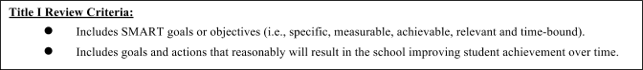

V. NCLB REQUIREMENTS - for Title I schools only

A. Instructional Program

- Explain how the instructional program(s) and strategies address the schoolʻs priority needs and ensure that students who are the lowest achieving receive effective and timely assistance.
RtI
Critical Thinking Skills
Liberal Arts Based Education

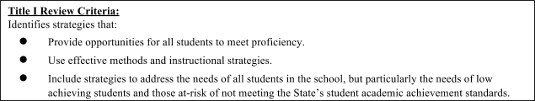

B. Instruction by Highly-Qualified Teachers

- Describe efforts to help instructional staff achieve highly qualified status (as defined by NCLB). Provide name and specific efforts for each non-highly qualified teacher.

- Note that highly qualified status is determined by classes taught. For example, a teacher who is licensed in math and teaches four math classes and two science classes is not highly qualified for the two science classes.

At the current time, all VSAS teachers are 96% HQT status for the classes that they teach.

- Describe efforts to recruit and retain highly qualified instructional staff (as defined by NCLB).

Recruitment and retention of highly qualified staff will be done through equal opportunity advertisements that require candidates to demonstrate minimum qualifications of highly qualified status or certification for the areas in which they are applying. Professional development opportunities, support and encouragement to implement creative but effective instructional strategies that relate to the arts or sciences are believed to increase retention of teachers.

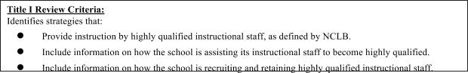

C. Professional Development

- Describe the professional development activities that are planned, including efforts to help instructional staff attain highly qualified status (as defined by NCLB) and efforts to strengthen instruction at the school.

Professional development will be provided for:
Add new trainings
- Student Engagement
- Responsive Classroom
- Positive Discipline
- Anti-bullying Strategies
- Designing Rubrics/Standards Based Grading
- Data Collection in the Classroom
- FBA process for data collection and intervention (RtI process)
- Classroom Culture and Instruction (Responsive Classroom)
- Coaching & Training
- Technology (MobiMax, software uses, etc.)
- New Math Curriculum (Eureka & Primary Mathematics)
- Singapore Math
- Online Reporting (depending upon if system is selected and purchased)
- Project Based Learning
- Common Core
- STEM
- Socratic Seminars/Essential Questions
- Response to Intervention

- Describe the teacher mentoring process

- Teachers are assigned to pods for support, information, and mentoring.
- Weekly pod meetings also provide regular communication between teachers.
- Bi-monthly Staff meetings provide regular meeting times and articulation between staff members and administration.
- The Learning Snapshots are helpful for providing feedback to teachers in areas relevant to the requesting teacher.
- Weekly POD Meetings are used to address professional and students learning as detailed in the guidelines. Responsibilities of each POD include; Address Student Support and Transition Issues, Refine & Align Curriculum, Instruction & Assessment, Engage in Professional Development, Reflection & Growth, Address Operational Issues and Examine Student Work.
- New teachers will attend a new teacher induction program to orient them to the school’s mission and vision as well as to the school’s systems and processes.
- Ineffective teachers, as established by the previous year’s evaluation, will receive additional support through review of their lesson plans, regular observations, and mentoring

- Explain how these activities will help achieve the school’s goals/objectives.

All of the professional development activities are directly related to the stated goals and objectives. All of them are also related to the improvement of student achievement by addressing specific reading and math skills, and the school’s learning environment.

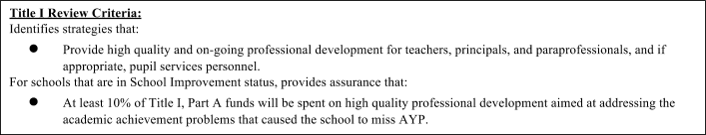
D. School and Family Partnership

- Describe the strategies, training, and activities that will increase school and family partnerships to support your school’s goals and objectives.

- The existing family involvement programs will remain in place.
- More opportunities for parent feedback will be sought using varied input strategies beyond meetings (i.e., electronic survey, incentives for participation, etc.)
- More communication in varied methods will be facilitated on a more consistent basis

- Describe how the strategies, training, and activities will be evaluated and monitored.

- Attendance at each event will be taken
- Feedback/Survey forms will also be collected to determine participant satisfaction and effectiveness
- Annual school-wide surveys will continue
- Shorter surveys will be taken on more defined topics to determine parent preferences feedback

- Describe links to other family support services.

- District DOE Office for special education and related services
- Family Guidance Center for mental health services
- BISAC – Big Island Substance Abuse Council
- Police
- Private providers (such as psychologists, psychiatrists, family therapists, mental health counselors)
- Department of Human Services

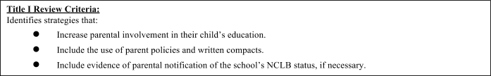

E. Transition

- Describe what program(s) and/or supports are available to students entering kindergarten.

- Before school orientation by the Kindergarten teacher
- General school orientation by a school official, usually the Education Director
- Individualized classroom visitations upon approval by the classroom teacher the year prior to the start of school
- School counselor for support

F. Coordination of Programs

- Describe how the Title I program will be coordinated with other programs, partnerships and grants in the school and community to deliver services that support the school’s instructional program. Other programs, partnerships and grants may involve cultural organizations, economic sectors/initiatives, nonprofits and/or professional organizations.

We have been working with a number of community agencies that support our school and its academic goals. For example:
- The Volcano Store and True Value Hardware in Volcano collect donations for us so that we can support educational trips for students to Kahoolawe. Not only is this an opportunity for students to develop community values, work ethics, teamwork, and independence, they also learn about biology and Hawaiian history;
- The Volcano Garden Arts, Hawaii Volcanoes National Park, and Three Mountain Alliance provide resources for us in relation to arts or sciences through which we students learn about themselves and their environment;
- PBS Hawaii through Hiki No for digital media production, editing, interviewing, script writing, journalism, problem-solving, and other related skills;
- HTS and HPM for our school campus development and science projects related to boat building and renewable electricity ideas.
Professional Organizations that we have been working with for Professional Development have been:
- ASCD for leadership development;
- Coalition of Essential Schools for professional development and communication strategies;
- Reading and Writing Perspectives by Ruth Ann Santos for reading related Professional Development for all staff;
- MobyMax for increased instruction in common core areas.
- Read Naturally subscription for supplemental reading practice and assessment.

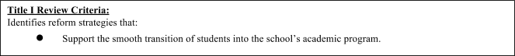
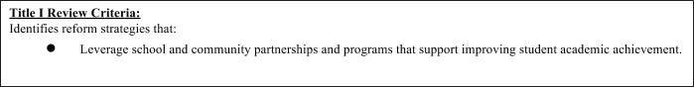
VI. CNA & ALIGNMENT REVIEW CRITERIA – All schools
Review of Comprehensive Needs Assessment and Alignment of CNA to Academic Plan
- Review the Schoolwide Plan for the following CNA and alignment criteria.
- Mark “Yes” in the column to confirm that the Schoolwide Plan meets each of the criteria.

Analysis Questions | Yes | No | Reviewer Comments  For peer review
Does the CNA reflect a comprehensive assessment of the needs of the school? | X |  | If no, what did the CNA not address?
Does the CNA extract the root causes of low student achievement? | X |  | If no, what are the issues the school should address:
Is there evidence to support the identified root causes? Are they sound? | X
Do the strategies and actions in the school academic plan align (address) the root causes of low student achievement? | X
Is the school academic plan focused and substantive to sustain continuous school improvement? | X
Title I only: Do activities in the FRF support the school academic plan? | X

VII. SCHOOLWIDE COMPONENTS CROSSWALK – Title I only
Review of Title I, Part A Schoolwide Components
- Review the Schoolwide Plan for the following required Schoolwide Components (all schools) and School Improvement Elements (schools in Priority or Focus status).
- Mark the “Yes” column to confirm that each element and/or component is included in the Schoolwide Plan
- Indicate a page number or other reference in the “Location of Evidence” column where each component and element is addressed in the Schoolwide Plan.

Schoolwide Components  To be completed by all schools. | Yes | No | Location of evidence within plan (e.g. page #’s) | Reviewer Comments  For peer review
Does this plan:
1. Incorporate a comprehensive needs assessment?

2. Identify school wide reform strategies?

3. Provide instruction by highly qualified teachers?

4. Provide high quality & on-going professional development?

5. Implement strategies to attract high quality, highly qualified teachers?

6. Implement strategies to increase parental involvement?

7. Incorporate transition plans?

8. Include teachers in decisions?

9. Ensure students most in need, receive effective & timely assistance?

10. Coordinate & integrate with other federal, state & local programs & services?

VIII. TURNAROUND PRINCIPLES CROSSWALK – Priority and Focus schools only
Review of Intervention and Supports based on Turnaround Principles for Priority and Focus Schools – for Priority and Focus schools only (both Title I and non-Title I)
- Review the Schoolwide Plan for the following Turnaround Principles for Priority and Focus schools.
- Mark checkboxes as appropriate to indicate the interventions and supports that are included in the School Plan.
- Note: Priority schools must have at least one checkbox marked for each turnaround principle.
- Indicate a page number or other reference in the “Location of Evidence” column where evidence

 | Principle | Interventions and Supports  Priority Schools - Implement all SEVEN principles over three years  Focus Schools - Implement at least ONE principle over one year | Location of Evidence  in School Plan  (e.g. page #’s and Goal, Objective, Strategy/Activity) | Reviewer Comments
1. | Providing  strong leadership | ▢ A performance review of the current principal and intensive, targeted professional development on how to turnaround a low performing school.  Priority School Plans must also include at least one of the bullets below, based on the results of the school improvement review (Optional for Focus School Plans):  ▢ A principal mentor.  ▢ Replacement of the principal. | Goal 1, Strategy 1e  Goal 3, Strategies 3a, 3c, 3d
2. | Ensuring  teachers are effective and able to provide improve instruction | ▢ Coaches (e.g. data coaches) to work with school level teams on analysis of performance trends and curricular interventions.  ▢ Job-embedded, ongoing professional development that reflects the needs identified by an educator effectiveness system. | Goal 1 Strategy 1c, 1e  Goal 2 Strategies 2a, 2b, 2c, 2d  Goal 3, Strategies 3a, 3c, 3d
3. | Redesign the  school day, week, or year | ▢ Analysis of how school time is currently used based on total minutes, minutes allocated for class time, and actual minutes dedicated to instructional time.  ▢ A strategy, grounded in research and best practices, to maximize time dedicated to educator collaboration, data teams, professional development, and class time dedicated to innovative methods of delivering instruction.  ▢ If appropriate, based on the school improvement review, School Plans may also extend the school day or year in a manner that results in increase time for innovative methods of delivering instruction.
4. | Strengthen  the school’s instructional program | ▢ Analysis of implementation of curricular materials for ELA and mathematics.  ▢ Strategy for implementation of a rigorous, research-based curriculum, for content areas outside of ELA and mathematics that is aligned to the Common Core, where applicable.  ▢ Review of instructional practices for alignment to the state standards and relevant curricular materials.  ▢ Targeted professional development on leveraging technology to support strong instructional practices, state standards, and implementation of high quality curricular materials. | Goal 1  Strategies 1a, 1b, c, 1d, 1e  Goal 2 Strategies 2a, 2b, 2c, 2d  Goal 3, Strategies 3a, 3c, 3d
5. | Using data to  inform continuous improvement | ▢ An analysis of existing professional learning team structure to establish a more effective school level structure for data analysis.  ▢ Intense, targeted professional development on formative assessment and targeted student interventions. | Goal 3 Strategy 3b
6. | Establish a  school environment that  improves safety and discipline | ▢ Analysis of the implementation of school- wide Response to Intervention with the goal of measuring the effectiveness of positive behavioral supports and interventions.  ▢ Analysis of anti-bullying policies and processes and wraparound services to address non-school challenges.  ▢ Analysis of disciplinary data and strategies to address school specific trends. | Goal 1, Strategies 1b, 1d, 1e  Goal 2, Strategy 2c
7. | Engage  families and communities | ▢ Strategies to identify and work with community partners and review existing communication processes to develop a comprehensive plan that focuses on engaging families and communities, includes multiple languages (based on student body demographics), includes multiple delivery methods, and includes strategies for follow up.  ▢ Curriculum planning that incorporates student interests and family and cultural backgrounds as part of curriculum planning with the goal of increased student achievement and engaging community partnerships. | Goal 1, Strategy 1b, 1d, 1e  Goal 2, Strategy 2c  Goal 3, Strategies 3a, 3c, 3d

IX. ASSURANCES

We, the undersigned, certify that to the best to our knowledge the Schoolwide Plan for Volcano School of Arts & Sciences meets the following criteria, as applicable.

All Schools:
(1) A comprehensive needs assessment was employed to identify indicators of need in selected areas of concern to prioritize needs, and to identify potential solution strategies to meet those needs.

Title I Schools only:
(2) The review of the school’s Schoolwide Plan was employed to identify Title I Schoolwide Components and/or Title I School Improvement Elements. These components and school improvement elements are essential facets of the Title I program.

Focus and Priority Schools only:
(3) The review of the school’s Schoolwide Plan was employed to identify implementation of the turnaround principles as defined in the Strive HI Performance System.

Director Signature |  | Date

~ * ~ * ~ * ~ * ~ * ~ * ~ * ~ * ~ * ~ * ~ * ~ * ~ * ~ * ~ * ~ * ~ * ~ * ~ * ~ * ~ * ~ * ~ * ~ * ~ * ~ * ~ * ~ * ~ * ~ * ~ * ~

The following individuals have peer reviewed the school’s Schoolwide Plan and/or provided technical support to the school’s director and/or Title I coordinator.

Peer Reviewers:

Reviewer Signature |  | Title
Reviewer Signature |  | Title
Reviewer Signature |  | Title
Reviewer Signature |  | Title
Reviewer Signature |  | Title

Attach
Appendix 1: Longitudinal System Data Profile
Appendix 2: Student, Parent, and Staff Questionnaires

Appendix 3: Roster of Instructional Staff - for Title I Schools only
- Complete all of the information in the following tables. If
Not needed

NON-HIGHLY QUALIFIED TEACHERS
Name | Grade(s)/  Subject(s) of Instr. | Degree(s) Held or years of Higher Ed | Licenses/ Certifications  (incl. state if not Hawaii) | PD Plan in PDE3  (Y/N) | Start Date at School | List Years NHQT

ALL OTHER INSTRUCTIONAL STAFF: Educational Assistants, PPTs
Name | Grades/  Subject of Instr. | Degree(s) Held or years of Higher Ed  (If none, write “none”) | Licenses/ Certifications  (e.g. ParaPro certification) | Date of License | Start Date at School | FTE

